INTRODUCTION

Project Context

The Student Affairs Office (SAO) at STI College Sta. Maria oversees the organization and management of student events and activities. According to Mr. Ryan Mel Sy Policarpio, Student Affairs Officer at STI College Sta. Maria, the SAO, follows a step-by-step process to ensure events comply with school rules and procedures, and to encourage student participation.
According to Ms. Lara Camille V. Vergara, former COMSOC Adviser, the process begins when student organizations or departments submit an event proposal for approval. The event must be scheduled at least one month in advance. For SHS clubs, events must not be scheduled within two weeks before exams. The proposal requires the signatures of the club president, vice president, and adviser for endorsement.
Ms. Vergara also mentioned that proposals can come from other units such as the Guidance Office, faculty members, alumni, or the Placement Officer. Organizers must clearly indicate the intended scope of the event, whether it is for the entire campus, school-wide, specific departments, year levels, SHS clubs, individual classes, or for staff and faculty only. Events intended for the entire campus must be organized directly by the Student Affairs Office.
After a student organization president submits their activity proposal, it must first be reviewed and signed by Mr. Ryan Mel Sy Policarpio, the Student Affairs Officer. Once signed, the student organization president is responsible for getting further approvals. These include the activity proposal, budget proposal if the event requires funding, and property borrowing. The student organization president must secure the signature of Ms. Lara Camille V. Vergara, Program Head of Information & Communications Technology (ICT) department, Mr. Allan Badilla Jr., Program Head of Business & Management (BM) department, Mr. Romeo Olympia, Program Head of General Education Courses (GE) department, and for the Senior High School Ms. Mary Grace Pangilinan, the Assistant Principal then Ms. Jazmin D. Mateo, the Academic Head, and Mr. Denmark Bron Mendoza, the School Administrator. For technical resources such as computers or projectors, the signature of either D. Panganiban or R. Regino from the Management

Information System (MIS) department is required. Suppose the event requires equipment or materials, such as tables, chairs, or speakers. In that case, approval must be obtained from Mr. Rommel Atilano of the Property and Asset Management Office (PAMO) and Ms. Edelyn Magayanes of the Building Administrator (BA). Once approved, the organizer must prepare and submit their request for student organization funds within five working days. After that, the organization must coordinate with the Student Affairs Office to verify the venue reservations and allocate necessary items or assets, such as computer units, TVs, speakers, tables, chairs, and other tangible materials. Additionally, appoint a staff member to manage the logistical arrangements, ensuring the event is executed efficiently, and assign someone to clean up after the event.
According to Ms. Nicole Andrea Jean Tadaya, President of Junior Philippine Institute of Accountants, following the completion of the event, a comprehensive narrative report, detailed evaluation, and liquidation report, if a budget proposal was submitted, will be prepared and submitted to Mr. Ryan Policarpio within three to five working days. However, if the liquidation report does not match the attached receipts, it will be returned for correction and proper reconciliation.
According to Ms. Jazmin D. Mateo, the Academic Head, activity forms are submitted to her so she can check the availability of rooms and facilities. She reviews the proposed event date to see if the requested rooms are available or if adjustments, such as room swapping, are needed. She requires that the activity form be submitted at least two days prior to the event to allow sufficient time for proper coordination.
STI College Sta. Maria has a total of 26 rooms, including 18 rooms with a capacity of 40 to 50 people, and eight rooms that can accommodate up to 30 people. There are also four computer laboratories and one of each of the following facilities: PE area, multipurpose hall (MPH), physics laboratory, and library. The library is generally reserved for special events only.
One of the main problems Ms. Mateo identified is the frequent double booking of rooms and overlapping schedules. This is due to the high demand for limited space and the lack of a proper system to track room availability in real time.

According to Mr. Renier Luzada, former Building Administrator, event forms must clearly specify the exact date and whether the requested resources will be used on Day 1 or Day 2 of the event. This level of detail is important for proper planning and scheduling. He emphasized that last-minute requests are not accepted due to limited resources and the risk of overlapping usage or borrowing conflicts. Proper coordination is required to ensure that all equipment and facilities are available and used efficiently.
Sir Rodel Regino and Sir Dharel Panganiban suggested the need for a system that provides notifications or reminders about upcoming events. They also emphasized the importance of having a calendar view that shows the event date, time, and the specific facilities to be used. They recommended that the system should allow them to leave comments on the borrowing forms submitted by organizers and include a remarks section indicating the names of individuals involved in the event. This will help in identifying their whereabouts if needed. Additionally, they mentioned that reports should be generated, and in most cases.
According to Mr. Policarpio, one of the significant concerns regularly faced by the SAO is scheduling conflicts and double bookings, which typically occur three to five times each semester. These issues often arise when multiple student organizations submit venue requests simultaneously through various channels, such as paper forms, email, and social media messengers. Without access to a centralized and real-time booking system, it becomes difficult to monitor the venue availability, resulting in overlapping reservations.
Mr. Ryan Mel Policarpio explained that the current event approval process often causes delays because it requires multiple physical signatures from faculty members and administrators. For example, after the Student Affairs Office reviews a proposal, it still requires signatures in person from the Program Head, Academic Head, School Administrator, and other relevant offices. Since many of these signatories are handling academic responsibilities and are not always available, organizers are forced to wait or follow up repeatedly, which slows down preparation and affects the finalization of event details.
He also mentioned that post-event evaluations are difficult to manage because organizers submit narrative and liquidation reports manually. These are often turned in late or incomplete, and the SAO has no way to verify compliance immediately. Mr. Policarpio

shared that there have been instances where reports were submitted without matching receipts, resulting in the documents being returned and revised. This creates a cycle of corrections that delays report validation and weakens accountability.
According to him, communication is inefficient because there is no standard channel for updates. Organizers often rely on in-person conversations, emails, or messaging apps like Messenger to receive feedback and updates. Mr. Policarpio cited situations where students missed important changes, such as shifts in event schedules or room assignments, because the information was not communicated clearly or was sent too late.
Lastly, Mr. Policarpio highlighted the difficulty in managing student organization records. Without a centralized file or database, information such as previous event records, participant data, and group performance is stored across different platforms or even in hard copies. As a result, retrieving data for accreditation reports or performance reviews becomes tedious and time-consuming.
Many educational institutions worldwide have enhanced their operations and communication by adopting digital event management systems. These systems provide features such as automated scheduling, approval tracking, and real-time notifications, which contribute to more efficient and organized event coordination. While STI College Sta. Maria continues to utilize a traditional manual process, which presents an opportunity to further strengthen its event management approach. With the steady growth of student activities, implementing a structured and streamlined solution can help the institution handle events more effectively and sustainably.

Purpose and Description

EduSync is a digital event management system designed to assist the Student Affairs Office (SAO) at STI College Sta. Maria is organizing and overseeing student activities more efficiently. Its main purpose is to streamline event scheduling, approvals, and notifications or reminders, which makes the entire process quicker, more precise, and simpler to administer. By providing an online platform for submitting proposals, tracking approvals, booking venues, and managing resources, EduSync eliminates the need for manual paperwork and scattered communication methods, ensuring that event coordination runs smoothly.
One of the key advantages of EduSync is its ability to prevent scheduling conflicts. With a built-in real-time scheduling feature, users can instantly check venue availability, reducing the risk of double bookings. The system also streamlines the event approval process through button-click approval, minimizing delays and enabling event organizers to receive faster responses.
EduSync also enhances communication by providing automated notifications and updates. Students, faculty members, event organizers, and staff from the Student Affairs Office will receive instant updates regarding event approvals, changes, and important announcements. This feature ensures that all stakeholders are well-informed and can plan accordingly.
Another important feature of EduSync is its capability to store and manage student organization records. The system serves as a digital archive for student profiles, event histories, and participation records, making it easier for the Student Affairs Office to track involvement, generate reports, and maintain accurate documentation.

General Objectives

To develop Edusync, An Event Management System for STI College Sta. Maria, that streamlines scheduling and resource management, reduces approval delays, improves communication, organizes student records, and simplifies reporting and documentation.

Specific Objectives
- To design and develop a Web-based Event Management System that automates the scheduling and coordination of events within STI College Sta. Maria
EduSync will offer an online scheduling tool that allows users to easily check available dates and time slots for venues and equipment in real-time. This feature will help prevent double bookings, minimize last-minute rescheduling, and allow organizers to plan events more accurately and efficiently.

To provide an online platform for event approval that allows students, faculty and staff to easily requests, review and approve
Edusync will allow faculty and administrators to review and approve event requests online. This removes the need for manual signatures and physical routing of forms, speeding up the entire approval process.

To implement an event monitoring and notification module that automatically send email reminders
EduSync will automatically send updates and reminders to event organizers, approving faculty, and student participants through email or in-system alerts. This ensures that everyone is aware of the event status and any changes made.
- To develop a module that organizes student organization records in one place Edusync will store important information, including student member lists, a list of officers, previous events, and the names of faculty advisers. This helps the Student Affairs Office (SAO) to track involvement and manage organization activities efficiently.

To generate detailed reports and analytics on event attendance, participation trends, and feedback results
EduSync will collect data from events and store it for future use. It will help generate summary reports on student participation, event evaluations, and required financial or liquidation documents that support school accreditation and planning.

Scope

Student Officer User Level
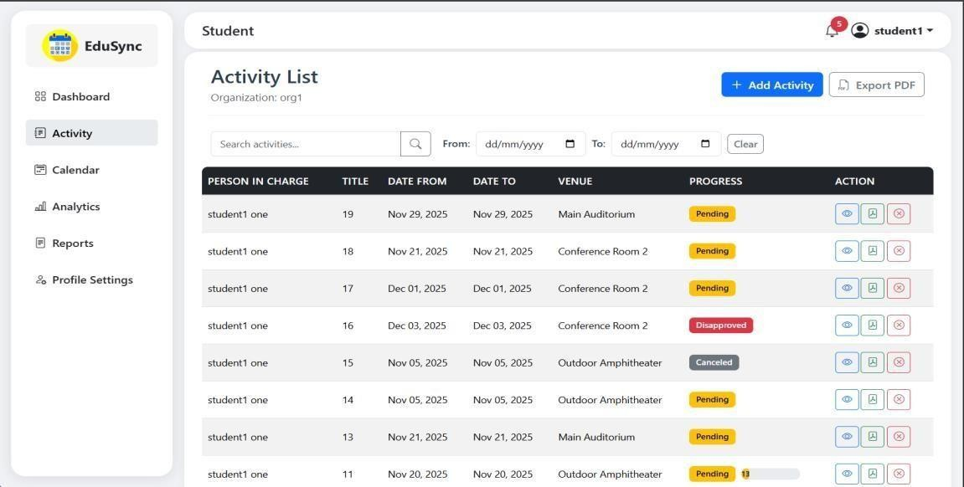
Figure 1: Activity List
Real-Time Status Tracking - Students can monitor the progress of their event requests in real time, receiving timely updates on approvals, rejections, or required revisions.
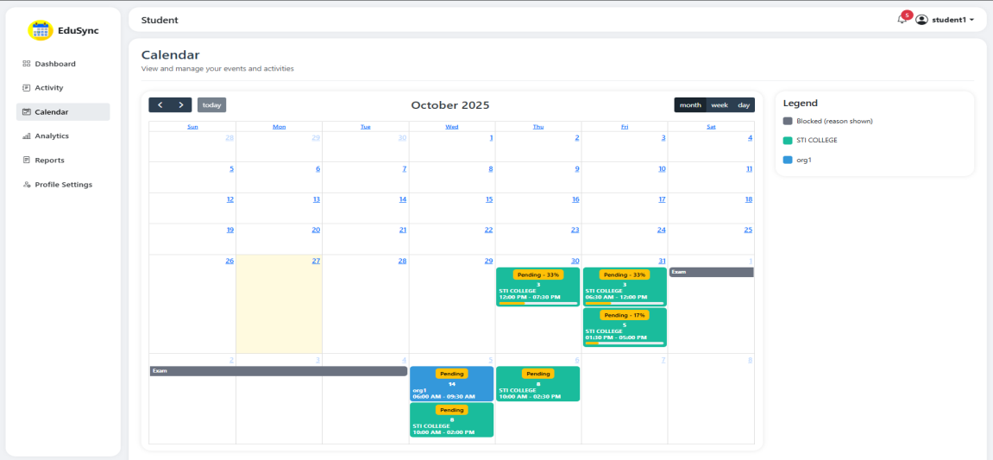
Figure 2: Calendar
Event Scheduling - Students will be able to view and align their organization’s event plans within a unified scheduling platform, helping to prevent overlaps and enhance coordination across campus activities.

Admin/SAO Level
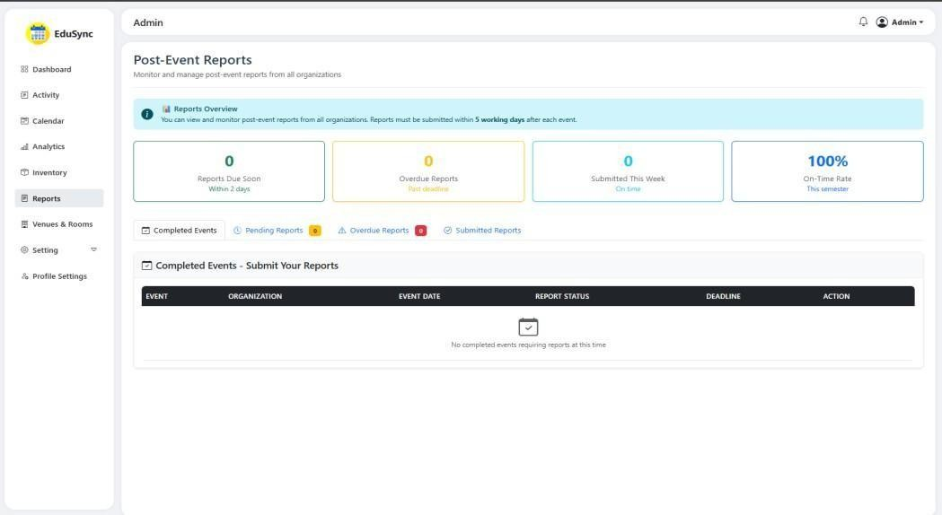
Figure 3: Post-Event Reports
Reports and Event Data - Staff can generate reports and access event histories to inform future planning and meet documentation requirements.
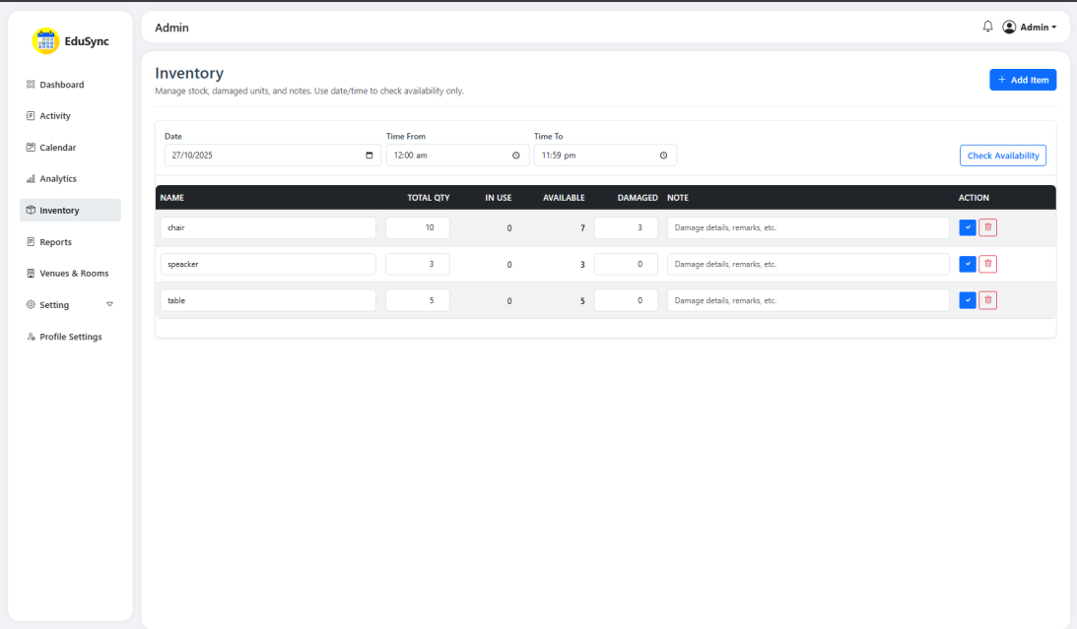
Figure 4: Inventory

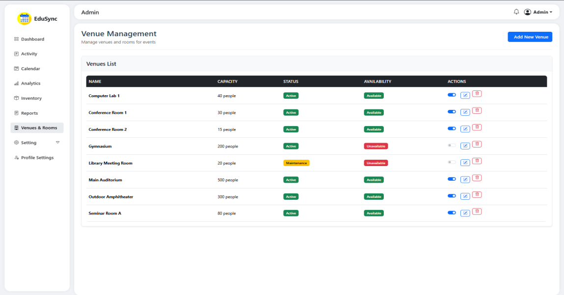
Figure 5: Venue Management
Venue and Resource Management - Staff can manage reservations for venues and resources in real time, ensuring proper allocation and avoiding overlapping scheduling.

Approver Level
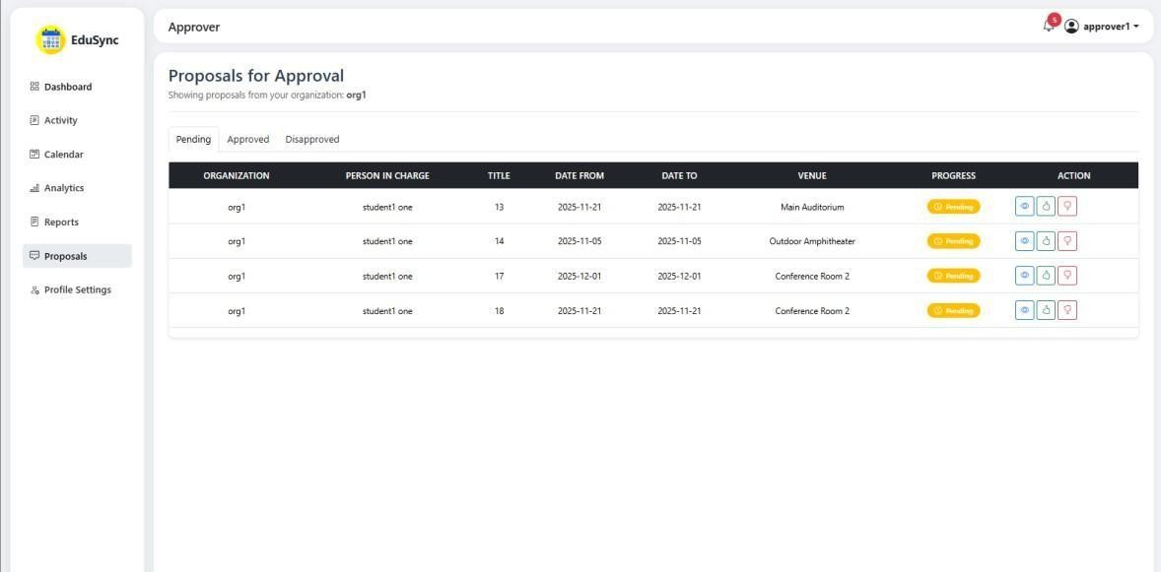
Figure 6: Proposals for Approval
Approve Event Requests - Faculty members are involved in the digital approval chain, where they can review and endorse proposals from the student organizations they advise.

Limitations
- Dependence on Internet Connectivity
EduSync requires a stable internet connection to function correctly. If the connection is lost during the submission of proposals or forms, any unsaved data may be lost, potentially resulting in delays or requiring the re-entry of information.

Restricted Permission Management
Only designated Admin or Student Affairs Office (SAO) personnel have the authority to manage user roles and access rights. Regular users, such as students or faculty, cannot adjust permissions or view specific proposal details without explicit admin approval.

No Support for E-Signatures
The platform does not allow the use of digital or electronic signatures. This limitation stems from concerns about the potential misuse of stored signature files and the absence of a secure verification system.

Students cannot Customize Forms
All event proposal forms and approval processes follow a standardized format. The system currently lacks customization options tailored to specific organizational needs or event types, which limits flexibility in planning specialized or non-traditional activities.

Registration Restriction
Only verified users can access the EduSync system. New users must request an account through the Student Affairs Office or the system administrator to ensure that only enrolled students, faculty, and staff from STI College are granted access. This helps maintain security and prevent unauthorized use of the platform.

REVIEW OF RELATED LITERATURE/STUDIES/SYSTEMS
Review of Related Literature Calendar Category Filter
Recent UX writing and pattern analyses (2020–2024) examine how filters are placed and behave in calendar UIs: side panels, top bar chips, drop-downs, inline toggle chips, and color-coded categories are common (Matkin, 2023). Best practices include clearly displaying active filters, supporting multi-select, offering “clear all” affordances, and providing immediate feedback (live calendar updates) rather than requiring a separate “Apply” action. Real-time feedback and prioritization of options (most used/most relevant) are recommended to reduce the user’s clicks and cognitive load.

Email Approvals

In 2020, organizations frequently relied on manual email threads for approvals, which research and practitioner surveys indicated were inefficient and prone to errors (Litmu’s, 2020). According to Litmus’ 2020 report, many organizations reported that approval processes in email workflows had become “more burdensome” due to additional departmental reviews

Email Notifications

Recent practitioner literature and vendor documentation from 2022 to 2025 recommend separate sending domains/subdomains for transactional and marketing mail, dedicated IPs (if volume warrants), retries on failed sends, and observability (monitoring for bounces, opens, spam complaints). Specialized transactional email vs. other forms of messaging can help increase reliability and reduce operations burden on student-/enterprise-facing notifications (Mailgun, 2024; SendGrid, 2023; Validity, 2025).

Auto-Generate Analysis
A newer interpretation of "auto-generate analysis" is systems that can take a dataset (tabular data, survey results, images, or instrument outputs) and automatically produce one or more forms of analysis, such as a structured summary, a visualization, or a natural language report. Key capabilities of this approach are pipeline automation (aka ETL, or

Extract-Transform-Load), machine learning, and Natural Language Generation (NLG). Surveys of the field of NLG/automatic report generation found that NLG methods (combining template writing with neural methods) are widely used to create reports from data.

Group Creation
Several other recent technical reports and conference publications describe custom "club management" or "student organization" systems. Such systems serve the purposes of creating and approving groups, collecting member information, dues, and attendance, and notifying students on their smartphones. Usability, role-based access (e.g., student leader vs. adviser or admin), and mobile-first user experience (UX) design are stressed to support system uptake. Implementation reports and product descriptions disclose universities using commercial systems (e.g., Suitable, AfterSchoolHQ) or in-house systems for administrative burden reduction.

Benchmarking

Features | Sched | Nextcloud | DocuSign | Tackle | Metabase | EduSync: An Event Management System for STI College Sta.  Maria
Calendar Category Filter  with status tracking |  |  |  |  |  | ✔
Email Approvals |  |  | ✔ |  |  | ✔
Email Notifications | ✔ | ✔ | ✔ |  |  | ✔
Auto-Generate analysis | ✔ |  |  | ✔ | ✔ | ✔
Group Creation |  | ✔ |  |  | ✔ | ✔
Table 1: Benchmarking Table

The comparison table above compares Sched, Nextcloud, DocuSign, Tackle, Metabase, and EduSync. EduSync comes with all basic features as well as a Calendar Category Filter to filter calendar events, along with a status-tracking feature. It had email approvals, email notifications, and auto-generated analysis, and it was capable of creating groups. EduSync was an all-in-one events management service for STI College Sta. Maria.

Review of Related Studies and/or Systems Sched
Sched provides real-time updates, QR code check-ins, and customizable event pages. Founded with a focus on flexibility and ease of use, Sched supports both virtual and in-person events. Importantly, Sched offers robust communication and engagement tools, making it a more lightweight and focused platform, primarily focused on event logistics and user experience.

Nextcloud

Nextcloud Hub is the industry-leading, fully open-source, on-premises content collaboration platform. Teams access, share, and edit their documents, chat, and participate in video calls, and manage their mail, calendar, and projects across mobile, desktop, and web interfaces. Nextcloud Enterprise gives professional organizations software optimized and tested for mission-critical environments.

DocuSign

DocuSign is a cloud-based electronic signature solution that enables individuals and businesses to securely sign documents online from anywhere, on any device. It transforms the slow, manual process of signing and managing agreements into a smooth, digital experience. DocuSign is part of a broader suite called the DocuSign agreement cloud, which includes tools for preparing, acting on, and managing contracts and agreements. Security and legality are at the heart of it all. DocuSign complies with strict global security standards and eSignature laws, such as ESIGN in the U.S. and eIDAS in Europe, ensuring that your digital signature is as legally binding as a signature on paper.

Tackle

Tackle is a calendar-based time tracking and productivity tool designed to help professionals and teams gain insight into how their time is spent. It works by integrating directly with popular calendar platforms, such as Google Calendar and Microsoft Outlook, allowing users to analyze, categorize, and visualize their time without needing to log hours manually.

Metabase
Metabase is easy-to-use data analytics and dashboarding solution that allows teams to examine data and generate visualizations without having a high level of technical expertise. An open-source business intelligence (BI) solution, Metabase allows users to ask questions about their data, see the answers graphically, and share their insights.

Synthesis

The investigation into the digital landscape of event management reveals a dichotomy. The robust project management software, adept at planning intricate tasks, and event-centric platforms excelling in live event logistics. However, a critical gap exists in seamlessly integrating these functionalities for a holistic event lifecycle management, particularly within the context of educational institutions like STI College Sta. Maria. Existing tools often lead to fragmented workflows because they lack specific features tailored to the unique needs of student affairs offices, which manage a multitude of events alongside student organization records.
EduSync directly addresses these limitations by providing a unified digital event management system specifically tailored for the Student Affairs Office (SAO) at STI College Sta. Maria. Unlike generic project management tools that may not fully address the nuances of event approvals and student engagement, and unlike standalone event scheduling tools that lack comprehensive organizational oversight, EduSync offers an integrated solution.
EduSync streamlines the entire event lifecycle, from the initial scheduling and resource management – a process often prone to conflicts and manual verification – to the automated collection of approvals, eliminating the delays inherent in paper-based systems. Furthermore, it enhances communication beyond simple notifications by centralizing announcements and updates, ensuring that all stakeholders, including students and faculty, are promptly informed—a significant improvement over the scattered emails and memos.
A key differentiator of EduSync is its built-in capability for managing students and organizations. This goes beyond basic event planning by creating a digital archive of student organization records, event histories, and participation data—a feature largely absent in generic event or project management software. This centralized database enables the SAO to track, report, and make informed decisions efficiently.

Moreover, EduSync's focus on generating reports and analytics tailored to the SAO's needs, such as participation summaries and financial reports, directly addresses the limitations of generic tools that may not provide education-specific reporting capabilities crucial for accreditation and continuous improvement.
By providing this tailored, integrated platform, EduSync aims to eliminate some of the manual processes and disparate systems, offering a modern solution that aligns with the digital transformation trend in education. It bridges the gap between event planning and managing student involvement and organizational records, ultimately fostering a more organized, communicative, and efficient campus environment at STI College Sta. Maria.

TECHNICAL BACKGROUND

Conceptual Model of the Study
INPUT
Knowledge gathering
- Data gathering via interviews.
- Research on RRL and RSS
Software Requirements
- Microsoft Application MS Word MS Teams Messenger OneDrive
- Google Chrome
- Visual Studio Code
- Figma
- Lucidchart
- Web technologies
- Programming Languages
Hardware Requirements
- Operating System Windows 11 Pro
- Processor:
11th Gen Intel(R) Core (TM) i3-1115G4
- Storage: 475Gb
- Keyboard
- Mouse
- Monitor: 1920x1080
PROCESS
- Planning
- Requirements
- Analysis
- Design
- Prototyping
- Implementation
- Maintenance
OUTPUT
- EduSync: An Event Management
System for STI College Sta. Maria

Figure 7: Input-Process-Output (IPO) Framework
EVALUATION

Input
The input phase serves as the foundation for the system development process. It involves gathering all necessary information, tools, and resources that will drive the subsequent stages of planning, analysis, and creation. This phase begins with extensive data gathering, primarily through interviews with the Student Affairs Office and other stakeholders involved in the approval process. These conversations uncover essential user needs, pain points, and functional requirements that guide the design of the system.
Alongside interviews, conducting research that focuses on both the Review of Related Literature (RRL) and the Review of Related Systems (RSS). These reviews will provide valuable insights into existing solutions and the theoretical framework, enabling the team to avoid redundancy and adopt best practices from academic and industry sources. To support project development, a suite of software tools has been prepared. These include productivity applications such as MS Word for documentation, MS Teams or Messenger for real-time collaboration, and OneDrive for secure cloud storage. For the development side, tools like Visual Studio Code are used for programming, while Figma and Lucid Chart assist in designing user interfaces, wireframes, and flow diagrams.

Process
The process will begin with system analysis and planning. Based on the data collected through interviews and research, the system’s structure, user roles, features, and functionalities will be defined. Tools like draw.io are used to create flowcharts, context diagrams, entity-relationship diagrams, and data flow diagrams that outline how each component of the system functions and interacts with other components.
From there, the design phase kicks in. Using Figma, the user interface (UI) and user experience (UX) layouts are created to ensure that the system is intuitive, responsive, and aligned with the user’s expectations.
Once the design is approved, development begins. Using Visual Studio Code, the programmer will write both the front-end and back-end code; however, with the help of other team members, the development process will progress much faster. Also, during this time, collaboration is ongoing through MS Teams and Messenger, where updates, reviews,

and feedback loops are actively managed. Files and progress are securely stored and synced in OneDrive, ensuring real-time accessibility.
This phase also includes testing and debugging to ensure the system is functional, secure, and reliable. The group will perform iterative testing to catch bugs, refine the workflows, and verify compliance with the help of a tester user.

Output
Following the procedures outlined in the process, the output will present the outcome of the research study or project titled EduSync: An Event Management System for STI College Sta. Maria. This project will benefit not only the Student Affairs Office but also the students who will utilize the system, particularly in proposing event plans, obtaining approval from the heads, and receiving notifications regarding the status of their proposals.

Technologies to be Used Internet Browser
This will serve as a gateway to a vast world of knowledge, allowing you to explore a wide range of information, from scholarly articles to real-time data and expert opinions. Whether it is needed to find recent studies, gather statistics, or deepen the understanding of related work, the browser provides quick and easy access to reliable sources that enrich the research.

Communication Tool

Platforms like Messenger and Microsoft Teams, which are accessible through the browser, allowed the team to stay connected at all times. Whether it was sending quick updates, holding virtual meetings, or sharing files instantly, these tools helped us collaborate smoothly, even when we were in the same place.

Integrated Development Environment

To develop and manage code efficiently during project development, use an Integrated Development Environment (IDE), such as Visual Studio Code (VS Code). This powerful tool provided a user-friendly interface that allowed users to write, test, and debug code all in one place. Features such as syntax highlighting, real-time error detection, and integrated terminal support helped streamline the development process. With the help of extensions, it can also connect to version control systems like GitHub and work collaboratively. VS Code played a crucial role in maintaining clean, organized, and functional code, ultimately supporting the technical backbone of the research project.

WordPress Software
Throughout the research project, word processing software, such as Microsoft Word, played a crucial role in writing and organizing the work. These tools can easily perform drafting, editing, and formatting of research documents. Features such as spell check, grammar suggestions, citation tools, and collaborative editing helped maintain clarity and consistency throughout all sections of the project.

User Interface (UI) / User Experience (UX)

In the research project, the researchers utilize UI/UX design tools, such as Figma, to create and refine the visual and interactive elements of the project. Figma is used to design user interfaces, prototype interactions, and visualize the user experience in a collaborative, cloud-based environment. Its intuitive drag-and-drop features, real-time collaboration, and version history enabled the team to iterate on designs and gather feedback quickly. Whether designing wireframes, high-fidelity mockups, or testing user flows, Figma helped bring out ideas to life, ensuring that the user experience was both functional and aesthetically appealing.

System Diagram Structure

As part of the research project process, using diagramming tools like Lucid Chart to create clear and structured system diagrams. These diagrams helped visualize complex systems, workflows, and relationships between different components of the project. Whether designing flowcharts, entity-relationship diagrams, or network structures, draw.io provides an intuitive interface with a wide range of templates and shapes.

Resources Hardware
Hardware Components | Hardware Specification
Operating System | Windows 11 Home Single  Language
Random Access Memory (RAM) | 16 GB
Solid State Drive (SSD) | 477 GB
Processor | 12th Gen Intel(R) Core (TM) i5 12450HX (2.40 GHz)
Peripherals | Laptop, Keyboard, and Mouse
Table 2. Hardware Resources

Software

Software Categories | Specific Software
Programming Languages | HTML, CSS, PHP, JavaScript
Framework | Laravel
System Diagram Structure | Draw.io
Integrated Development Environment | Visual Studio Code
Version Control Software | GitHub
Communication Tool | Microsoft Teams, Messenger
Word Processing Software | Microsoft Word
User Interface (UI) / User  Experience (UX) | Figma
Internet Browser | Google Chrome
Table 3. Software Resource

Software
HTML, CSS, PHP, JavaScript

These are the primary languages used to build and style the system: HTML and CSS for structure and design, JavaScript for interactivity, and PHP for server-side functionality.

Laravel

Laravel is a free, open-source PHP-based web framework for building web applications. It provides web developers with tools and resources for creating, deploying, and monitoring scalable web applications.

Draw.io

Draw.io is a tool used to create visual diagrams, such as flowcharts, context diagrams, entity-relationship diagrams, and data flow diagrams. This helps in planning and understanding our system design.

Visual Studio Code

VS Code runs smoothly without slowing down the system. It is also supported by multiple programming languages that are perfect for handling both front-end and back-end development of the system.

GitHub

GitHub is a platform for managing and storing code versions, enabling multiple developers to collaborate and track changes over time.

MS Teams, Messenger

These tools facilitate communication and collaboration, which are crucial for discussing updates, sharing files, and conducting meetings throughout the development process.

MS Word

MS Word is used for documenting, reporting, and creating or editing text documents.

Figma

Figma is a web-based tool used for designing user interfaces and planning user experiences, ensuring that the system is both user-friendly and visually appealing.

Chrome

Google Chrome serves as a powerful, efficient, and flexible tool for research, offering fast browsing, integration with Google services, privacy features, and numerous extensions that can enhance the research process.

Calendar of Activities
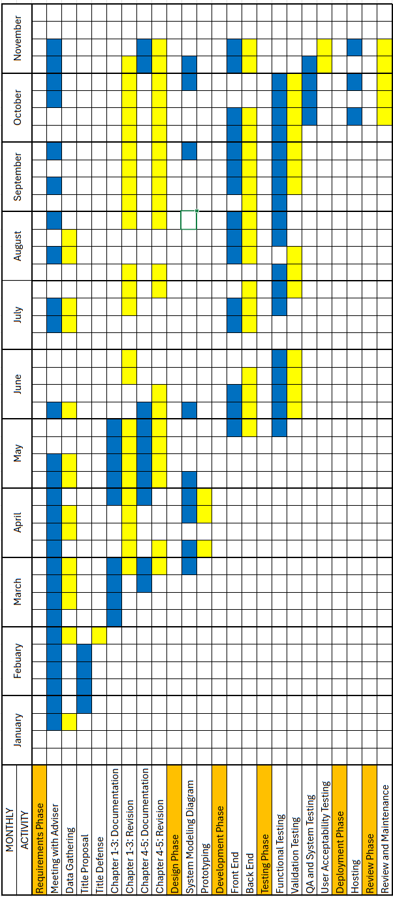
Table 4: Gantt Chart of Activities

METHODOLOGY

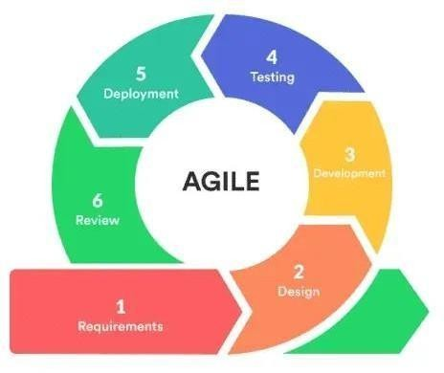
Figure 8: Methodology

Agile Methodology

The Agile Methodology allows the team to adapt to changing requirements and deliver updates more efficiently. This also works through iterative development and continuous feedback, ensuring the system meets user needs while maintaining high quality and flexibility.

Requirements

The requirements phase occurred from January to October, where developers worked closely with the beneficiary and adviser to gather, clarify, and prioritize user needs. Activities included meetings with the adviser and data-gathering tasks to capture system expectations. The team prepared the title proposal and underwent title defense to validate project direction. Chapter 1 documentation and subsequent revisions were completed to refine the problem, objectives, and scope. Chapter 2 documentation and revision also took place during this phase to further define system needs. The main goal was to ensure all requirements were clear, validated, and feasible for implementation in the next phase.

Design

From March to May, developers focused on creating simple and flexible design solutions aligned with the approved requirements. This included preparing Chapters 3 and 4 documentation, followed by revisions. System modeling diagrams were completed to describe workflows, structures, and data relationships. Prototyping activities were also conducted to visualize system functions and allow early user feedback. The objective of this phase was to produce a functional design that supports efficient implementation and can be refined throughout the project.

Development

The development phase took place from May to October, during which core system functionalities were built. Developers worked on both front-end and back-end components, writing and integrating code to ensure proper feature behavior. Iterative improvements were made throughout the period to refine system functions and address concerns. The main goal of this phase was to deliver a working version of the system that aligns with the approved requirements and design.

Testing

Testing activities occurred from June to October, where the system was evaluated to ensure proper functionality and performance. Functional testing was first conducted to validate basic behavior, followed by validation testing to confirm alignment with user requirements. Three IT professionals conducted QA and system testing on October to verify integration, usability, and security. Feedback gathered throughout testing supported bug fixing and refinements. The goal of this phase was to ensure the system is reliable, stable, and ready for deployment.

Deployment

Deployment took place in October, when the completed system was prepared for actual use. Hosting was configured so the system could operate in its live environment. Developers monitored performance and resolved any issues that emerged during early usage. The main goal of this phase was to deliver a fully functional and stable system suitable for real-world implementation.

Review

The review and maintenance phase also happened in October, where the development team assessed the system to ensure it met user needs and project goals. System performance, usability, and completeness were reviewed. Necessary improvements and maintenance activities were performed to enhance quality. The primary objective of this phase was to gather insights for refinement and to support continued system stability.

Requirements Analysis WHO – The People Involved:
Organizing student activities is a collaborative effort that brings together a diverse group of individuals from various offices and departments. At the heart of this process is the Student Affairs Office (SAO), which plays a vital role in overseeing and managing all student-related events.
Student Council Officers and Organization Officers from both Senior High and Tertiary levels are the driving force behind these activities. They initiate requests and are responsible for proposing and executing events, working closely with their Advisers – who include the President, Vice President, Secretary, Treasurer, and Auditor.
The Approval process involves several school officials, including the Program Head, Assistant Principal, Academic Head, and School Administrator. Additionally, supporting staff, including the Accounting Clerk, Guidance Office, Alumni and Placement Office, and Faculty Members, contribute at various stages. To enhance operational efficiency, the team requires a system that integrates all these roles and facilitates seamless coordination among all parties involved.
WHAT – The Business Activity:

The core of the business activity revolves around preparing, approving, funding, and documenting school-sanctioned events or projects initiated by student organizations. These events can range from educational seminars and outreach programs to sports festivals and cultural celebrations.
To get started, student organizations must submit key documents, such as activity forms, property borrowing requests, and proposals. After the event, they are required to submit narrative, evaluation, and financial reports. Each step in this process needs to be timely and organized to ensure accountability and compliance with institutional standards. The proposed system aims to streamline this entire process, allowing users to submit and track forms, receive digital approvals, and maintain a comprehensive record of all activities conducted by student organizations.

WHERE – The Environment:

These procedures occur within the school environment, specifically in offices related to student affairs and finance. Currently, many interactions happen in person, with students submitting physical forms to various offices. This manual approach can lead to delays, lost paperwork, and a lack of centralized monitoring.
The team's goal is to transition these interactions into a digital platform, enabling online submissions, tracking, and communication. With an accessible system, students and staff can easily view the status of their requests and meet deadlines more efficiently, even if they are unable to be physically present in the office.
WHEN – The Timing:

Timing is crucial for the success of each activity. Pre-event requirements must be submitted at least three weeks before the planned date. Allowing enough time for review, revision, and approval. Ideally, submissions should be made a month in advance to ensure everything runs smoothly.
After an event, organizations must submit their documentation, including the narrative report, evaluation report, and financial report, within five working days. Missing these deadlines can lead to delayed reimbursements, disapproval of future requests, or negative evaluations for the student organization. The system will include automated reminders and submission deadlines to help users stay on track and avoid any penalties.
HOW – Current Procedures:

The process begins when a student organization fills out the Activity Form and submits it for review. If they need equipment or materials, they also submit a Property Borrowing Form. A detailed Budget Proposal is prepared and reviewed by the appropriate authorities. Once approved, the organization can submit a Request for Student Organization Fund, which should be processed within five working days.
After the event, the organization is required to submit a Narrative Report detailing the event's progress, an Evaluation Report summarizing its effectiveness, and a Financial Report documenting all expenses incurred. The SAO and other relevant offices, such as the

Accounting Office, review these reports. The final approval and compliance checks are conducted by the MIS, PAMO, and BA departments.
Although this current system is effective, it relies heavily on paper and is prone to delays. The team's vision for a new software solution is to automate most of these steps, provide real-time updates, ensure data accuracy, and create a permanent digital archive of all transactions and activities. This will not only enhance efficiency but also make the entire process more user-friendly for everyone involved.

Requirements Documentation
The EduSync system is an event management system designed to streamline student organization submissions, approvals, and reporting. It enables students to create, submit, and track proposals while viewing calendar availability to avoid venue and schedule conflicts. Approvers review proposals according to assigned categories and provide decisions with comments through the system or secure email links. Administrators configure users, roles, venues, inventory, date restrictions, and reporting tools. Overall, EduSync supports faster proposal turnaround, consistent policy compliance, transparent statuses, and audit tracking.
The system allows secure sign-in, including optional Microsoft OAuth linking, and supports profile updates. Students submit proposals through a validated multi-step form, including details such as title, objectives, organization, leadership, dates, venue, and target reach. Proposals may include multiple activity days and budget line items. Statuses include pending, approved, disapproved, and canceled, and proposals may be viewed or exported as PDFs. The calendar prevents conflicts with other scheduled or pending activities.
Approval visibility depends on the user’s designated category: global approvers (such as BA, MIS, PAMO, Academic Head, School Administrator, and Student Affairs Office) may see all submissions, while advisers and program heads view only relevant proposals. Any disapproval immediately results in proposal rejection, and final approval requires all required categories to confirm. Approvers may dismiss notifications without taking action. Secure email tokens allow quick approval or rejection outside the system.
Notifications are issued upon submission, approval, or disapproval. The system prioritizes Microsoft-linked email accounts for messaging; otherwise, the default system email is used. A built-in messaging feature allows users to communicate with visibility limited to participants.
Administrators manage organizations, roles, permissions, venues, date rules, and inventory, including item details such as name, quantity, and condition. The system provides reporting tools for narrative, evaluation, and financial outputs, along with administrative dashboards.

Security measures include CSRF protection, secure password hashing, role-based access control, input validation, token safeguards, and proper output handling. Performance is supported through pagination, optimized queries, and queue-based task handling, while horizontal scaling may be applied. Reliability is ensured through soft deletes and structured configuration management. The system uses a responsive Bootstrap-based interface with clear status indicators.
EduSync requires modern client devices and browsers, a PHP-based Laravel backend running on Linux or Windows servers, and a MySQL-compatible database. Optional support for Microsoft Graph and SMTP is available. User types include students, approvers, and administrators. The database stores records for users, proposals, approvals, messages, inventory, and Microsoft access tokens. Development must follow institutional approval governance, prohibit self-approval, support audit logging, and allow deployment on campus or shared hosting environments.

Design of Software, System, Product, and/or Processes

This section presents the design of the EduSync event management system, covering the overall architecture, applied standards, selected technologies, quality and security measures, and validation activities prior to deployment.
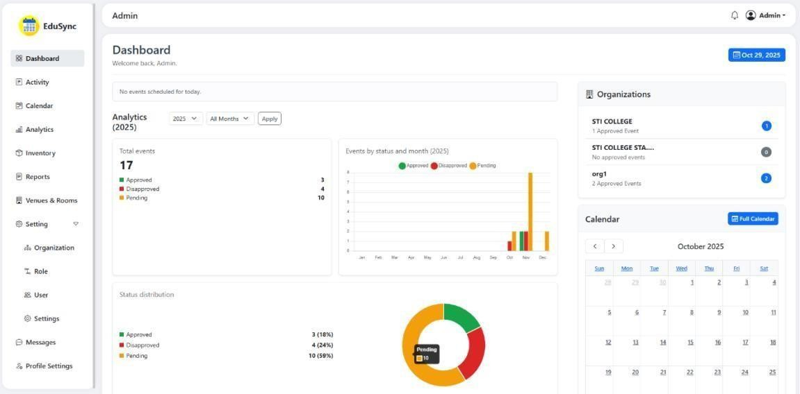

Figure 9: Dashboard

The EduSync Admin Dashboard gives a quick overview of event statistics, including the number of approved, disapproved, and pending activities, along with visual charts and a monthly calendar. It also displays organization activity and provides navigation to key modules such as Activity, Reports, Users, and Settings.
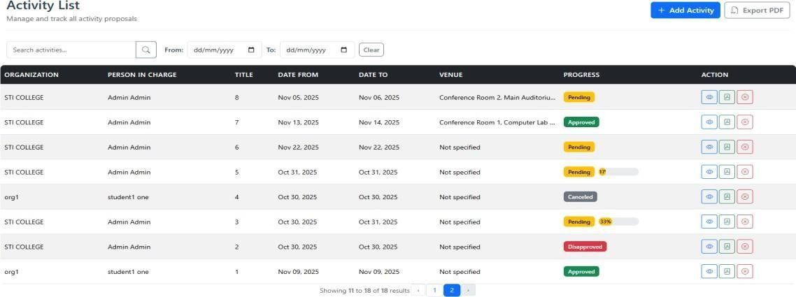

Figure 10: Activity List

The Activity List page displays all submitted activity proposals with details such as organization, person in charge, title, schedule, venue, and approval status. It allows admins to search, filter by date, view details, approve/disapprove, archive, add new activities, and export the list to PDF.
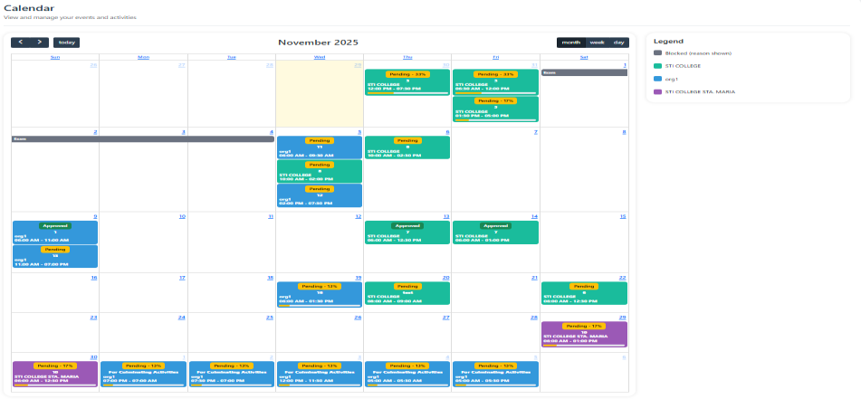

Figure 11: Calendar

The Calendar page provides a month-view schedule of activities, showing their dates, venues, organizations, and approval status through color-coded labels. It helps users visualize event distribution, view blocked dates, and switch between month, week, or day views.
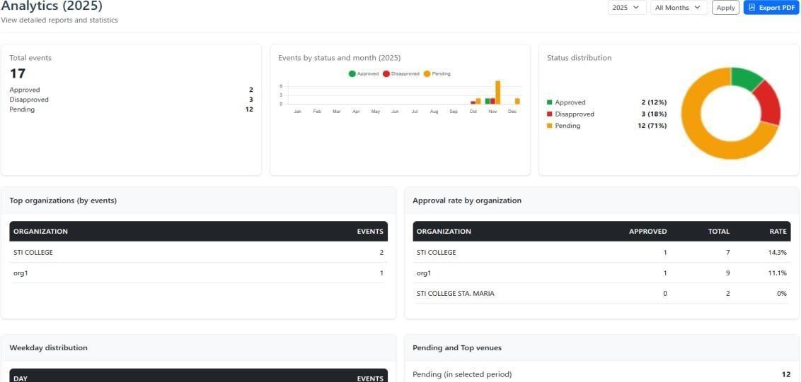

Figure 12: Analytics

The Analytics page summarizes total events for the selected period and visualizes their approval status through charts and graphs. It also highlights top organizations, their approval rates, weekday activity distribution, and venue insights, with an option to export data to PDF.
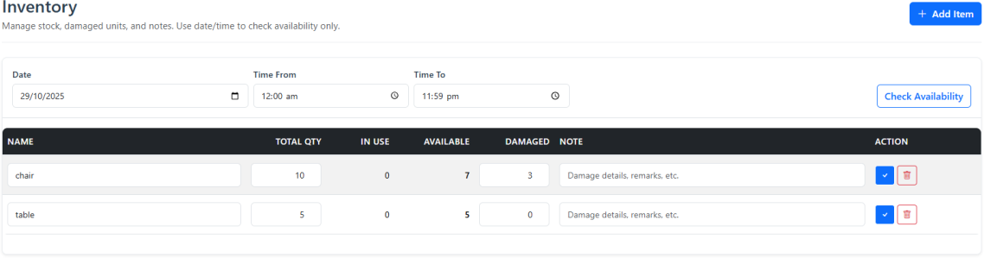

Figure 13: Inventory

The Inventory page lets users track items, check availability based on date and time, and manage total, in-use, damaged quantities, and notes.

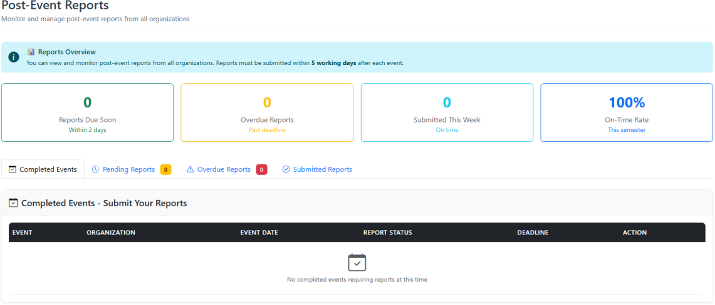

Figure 14: Post-Event Reports

The Post-Event Reports page tracks completed events and their report submissions, highlighting due, overdue, and on-time reports.

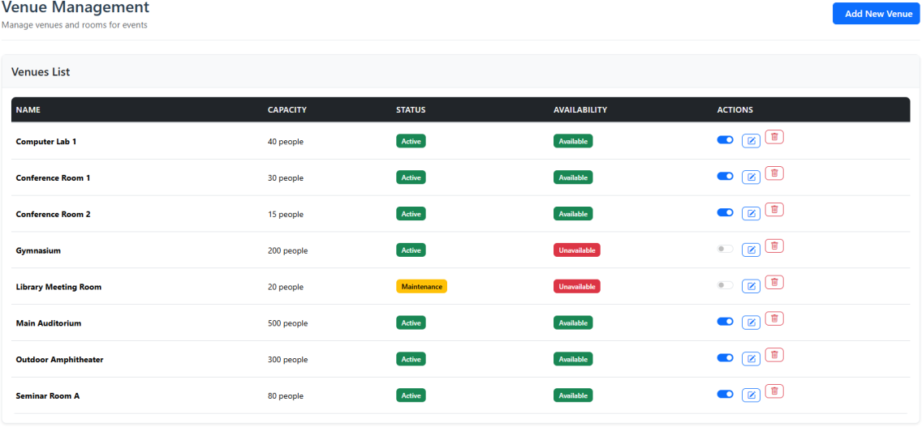

Figure 15: Venue Management

This Venue Management page lists all rooms, including their capacity, status, and availability, allowing administrators to add, enable/disable, edit, or delete venues.
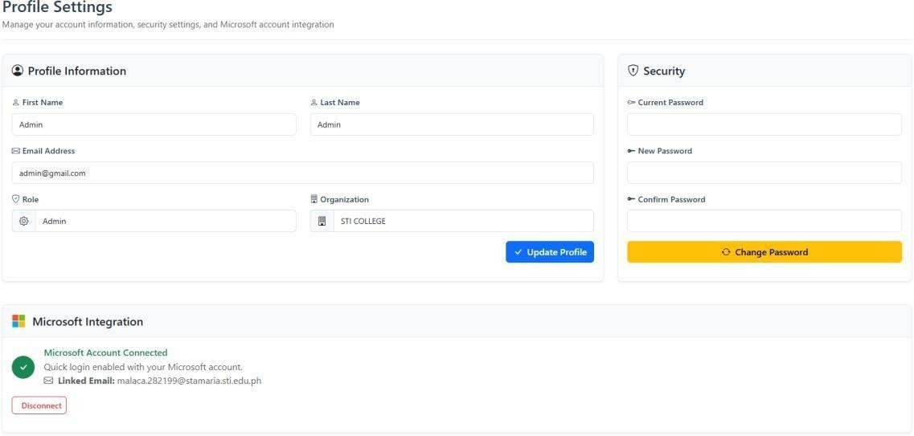

Figure 16: Profile Settings

This Profile Settings page allows users to update their personal information, organization, and role, as well as change their account password. It also shows Microsoft account integration status, displaying the connected email with an option to disconnect.

The system follows a multi-tier structure composed of the presentation, application, and data layers. The presentation layer provides user interfaces for proposal submission, review, and administration. The application layer handles workflows such as proposal routing, schedule checks, and approval processing. The data layer manages storage and retrieval of user, organization, and activity records. This design supports modular development, scalability, and easier maintenance.
The system design aligns with ISO/IEC 25010 for product quality attributes such as security, reliability, usability, and maintainability. IEEE/ISO testing standards guided evaluation activities, while OWASP practices were referenced to reduce vulnerabilities and ensure secure handling of user information.
The project utilizes Laravel for backend services, Blade for user interfaces, and MySQL for structured data storage. Git was used for version control, supporting iterative development and incremental refinement based on testing and feedback.
Quality and security were ensured through unit and integration testing, data validation, and strict authentication and authorization controls: password hashing, secure communication, and backup procedures preserved data integrity and availability.
The design was validated through requirements analysis, prototype evaluations, consultations with stakeholders, and security checks based on OWASP guidelines. These activities confirmed that the system met institutional needs and could efficiently support activity proposal processing.

Development

EduSync was developed using an iterative, modular approach to ensure alignment with stakeholder needs and institutional policies. Requirements were gathered through consultations with students, student advisers, program heads, and the Student Affairs Office, which informed the workflows for proposal creation, routing, and approval.
The system used a three-tier structure with Laravel for the application layer, Blade with Bootstrap for the presentation layer, and MySQL for data storage. Core features such as authentication, role-based access control, multi-step proposal submission, scheduling, and messaging were developed incrementally. Microsoft single sign-on, conflict detection, and category-based approval routing were also implemented to support secure and efficient processing.
Security was prioritized through CSRF protection, hashed credentials, input validation, and audit logging. Development followed ISO/IEC 25010 guidelines, emphasizing maintainability, usability, reliability, and security. Unit and integration testing validated core functions, including authentication, approval routing, administrative tools, and data handling.
Administrative functions supported management of users, venues, date rules, and inventory, while post-event modules enabled report submission and monitoring. A responsive interface with clear visual indicators supported ease of use. After testing and stakeholder validation, the system was prepared for deployment using documented configuration settings.

RESULTS AND DISCUSSION
Testing
As part of the system evaluation, the IT specialists conducted a series of manual test case scenarios aimed at determining the technical soundness, reliability, and efficiency of EduSync: An Event Management System in STI College of Sta. Maria. The assessment focused on key aspects such as system architecture, database functionality, interface performance, and security mechanisms. The IT professionals verified that the system demonstrated stable operation, efficient data processing, and consistent responsiveness across all modules. The specialists acknowledged the system’s well-structured design, which allowed seamless integration between event creation, scheduling, and participant management components, ensuring accurate data handling and minimal system errors.
User acceptability testing was performed to evaluate the system’s usability, accessibility, and overall user satisfaction among its intended users—students, faculty members, and event coordinators of STI College of Sta. Maria. Participants evaluated EduSync based on its interface design, ease of navigation, system responsiveness, and overall functionality. The results revealed that users perceived the system as highly intuitive and user-friendly, facilitating faster and more efficient event management processes. Respondents also emphasized that EduSync significantly reduced manual workloads and improved communication regarding institutional activities and announcements.
The results of both IT specialist evaluations and user acceptability testing demonstrated that EduSync successfully met the technical and functional standards necessary for institutional implementation. The IT specialists confirmed that the system was technically sound, secure, and operationally efficient, while end users expressed a high level of satisfaction with its usability and practicality. Although minor recommendations were noted, such as further enhancement of the user interface and mobile responsiveness, EduSync was found to be a dependable and effective platform for event management.

Description of Prototype
Edusync is an Event Management System that helps schools manage student activity proposals submitted, reviewed, and approved. Instead of using paper forms or long email exchanges, the system provides an online platform where students, advisers, and administrators can monitor proposal status and manage event information more efficiently.
The system allows students to prepare and submit activity proposals using a guided multi-step form. These proposals automatically follow an approval workflow based on department, organization, and proposal type. Approvers can read full proposal details, approve or disapprove, leave comments, and receive instant notifications. Students also receive updates, so they always know the current status of their request.
A built-in calendar manages venue schedules and prevents double booking. The calendar highlights pending and approved events and allows users to filter by date, venue, or organization. To support documentation, proposals can be downloaded as PDF files, and post-activity reporting (narrative, evaluation, and financial) can also be processed within the system.
The prototype is built using Laravel 12 (PHP) for backend logic and Bootstrap with Blade templates for the interface. MySQL is used for the production database, while SQLite may be used for development. The system supports Laravel Authentication and Microsoft OAuth 2.0 for secure login. Other tools include DomPDF for generating proposal PDFs, SMTP and Microsoft Graph API for emails, and REST-based integration for calendar and email syncing.
To ensure security, Edusync uses password hashing, role-based access control, CSRF protection, input validation, encrypted tokens, and audit-logging to track decisions and activities. All proposal records, user information, activity logs, and attachments are stored securely.

Implementation Plan
The implementation of Edusync, an Event Management System, aims to improve how student activity proposals are submitted, reviewed, and approved. The system will provide a web-based platform accessible to students, advisers, and administrators, allowing them to monitor proposal status and manage event information more efficiently.
Before deployment, the hosting environment will be prepared by configuring a web server with the necessary packages, including PHP and MySQL. The database will be created and configured to store all system data, after which the Laravel application files will be installed, environment variables configured, and system commands executed to ensure proper functionality. After setting up, the system will undergo thorough testing, including functionality checks and user acceptance testing, to guarantee that it meets user requirements.
The hardware requirements for the system include a server with at least a dual-core CPU, 4GB of RAM, and 50GB of storage, while clients can access the platform using any internet-enabled device. Software requirements include PHP 8+, Laravel 12, MySQL, Composer, Node.js, and a modern web browser such as Chrome or Firefox.
To ensure proper usage, users will undergo training sessions tailored to their roles. Students will be guided on submitting proposals and checking the status of their activities. Advisers will learn how to review, comment on, and approve proposals efficiently. Administrators and Student Affairs staff will be trained in full system management, including scheduling, resource allocation, and report generation. Training will be delivered through demonstrations, user manuals, and video tutorials.
System maintenance will be carried out regularly to keep the platform secure and reliable. This will include database backups, security updates, server monitoring, and prompt resolution of user-reported issues. Feedback will be incorporated into system improvements to ensure that the platform remains user-friendly and functional over time.
Potential risks include server downtime, unauthorized access, data loss, user errors, and system bugs. To mitigate these risks, backups will be performed regularly, multi-factor

authentication will be implemented, users will receive clear instructions, and continuous testing will identify and resolve bugs.
A projected budget includes costs for web hosting, domain registration, and miscellaneous expenses, totaling approximately ₱1,768 per year. Evaluation of the system will rely on user feedback, usage analytics, and tracking approval processing times. This will help identify areas for improvement and guide future updates.

Implementation Results

The table below presents the interpretation of the numerical ratings applied during the IT Specialist Evaluation of Edusync.

NUMERICAL VALUE | VERBAL INTERPRETATION
4.50 – 5.00 | Excellent
3.50 – 4.49 | Very Good
2.50 – 3.49 | Good
1.50 – 2.49 | Fair
1.00 – 1.49 | Poor
Table 5: Verbal Interpretation Numerical Value

The levels of agreement are the following 5 = Excellent
4 = Very Good 3 = Good
2 = Fair
1 = Poor

The formula for Weighted Average Mean is
WM = (E * 5) + (VG * 4) + (G * 3) + (F * 2) + (P * 1)
TNR

Where:
WM = Weighted Average Mean E = Excellent
VG = Very Good G = Good
F = Fair P = Poor
TNR = Total Number of Respondents

CRITERIA | STATEMENTS | Weighted  Mean | Verbal  Interpretation
 | Data Design – Proper | 4.67 | Excellent
 | normalization, | 4.67 | Excellent
 | relationships, efficiency | 4.67 | Excellent
 | System Architecture – | 4.67 | Excellent
 | Clear layering, | 4.67 | Excellent
System Design | modularity, scalability | 4.67 | Excellent
& Architecture | Code Quality – | 4.33 | Very Good
 | Readability, | 4.33 | Very Good
 | maintainability, and | 4.33 | Very Good
 | standards followed | 4.33 | Very Good
 | Integration – Smooth | 5.00 | Excellent
 | interaction with APIs, | 5.00 | Excellent
 | third-party tools, or | 5.00 | Excellent
 | external systems | 5.00 | Excellent
 | Core Features – All | 4.67 | Excellent
 | requirements are | 4.67 | Excellent
 | implemented | 4.67 | Excellent
 | Reliability – Stable, | 4.33 | Very Good
 | minimal bugs, error | 4.33 | Very Good
 | handling | 4.33 | Very Good
 | Performance – Fast | 5.00 | Excellent
Functionality | response, optimized | 5.00 | Excellent
& Performance | queries, efficient resource | 5.00 | Excellent
 | usage | 5.00 | Excellent
 | Compatibility – Works | 5.00 | Excellent
 | across intended | 5.00 | Excellent
 | platforms/devices | 5.00 | Excellent
 | Scalability – Can handle | 4.67 | Excellent
 | growth in users/data | 4.67 | Excellent

CRITERIA | STATEMENTS | Weighted  Mean | Verbal  Interpretation
User Interface & Usability | Design – Clean, professional, consistent  look | 3.67 | Very Good
User Interface & Usability | Usability – Intuitive  navigation, ease of use | 3.67 | Very Good
User Interface & Usability | Accessibility – Consideration for different users (e.g., readability, device  access) | 3.33 | Good
User Interface & Usability | Responsiveness – Layout  adapts across devices/screens | 3.33 | Good
User Interface & Usability | Error Feedback – Clear,  helpful error messages and validation | 3.67 | Very Good
Security Evaluation | Input Validation – Proper handling of user inputs to prevent SQL Injection  and Command Injection | 4.00 | Very Good
Security Evaluation | Authentication – Secure login (hashed passwords, sessions, MFA if  applicable) | 4.67 | Excellent
Security Evaluation | Authorization – Proper role-based access control (users can only access  allowed data) | 5.00 | Excellent

 | Data Protection – Sensitive data encrypted in transit (HTTPS/SSL)  and at rest | 4.67 | Excellent
 | Session Management – Secure cookies, session  timeout, logout handling | 4.00 | Very Good
 | XSS & CSRF Protection – Proper escaping, tokens, and headers  implemented | 4.33 | Very Good
 | Error Handling – No sensitive system information exposed in  error messages | 5.00 | Excellent
OVERALL MEAN |  | 4.37 | Very Good
Table 6: IT Specialist System Evaluation Results

Based on the IT Specialists System Evaluation Results, the system achieved an overall mean of 4.37, which is interpreted as Very Good. This shows that the system performed well across all system evaluation criteria and meets the expectations of the IT Specialists.
For System Design and Architecture, the system obtained a mean of 4.67, interpreted as Excellent. The IT Specialist rated most aspects as Excellent, particularly in Integration (5.00) and Data Design (4.67), commending the system for its efficient structure, clear data relationships, and smooth modular design. The architecture’s scalability and organization were seen as proof of thoughtful technical planning and adherence to good development practices.
For the Functionality and Performance, the system obtained a mean of 4.73, interpreted as Excellent. The IT Specialist recognized the system’s reliability and optimization. With

Performance (5.00), Compatibility (5.00), and Scalability (4.67) rated as Excellent, the evaluator noted that the system performs consistently across platforms and can efficiently handle larger workloads and user growth. The minimal occurrence of bugs and the system’s fast response times were highlighted as indicators of quality engineering.
For the User Interface and Usability, the system received a mean of 3.53, interpreted as Very Good. The IT Specialist gave lower but still positive ratings, ranging from "good" to "very good." The Design (3.67) and Usability (3.67) were appreciated for their clarity and ease of use, but Accessibility (3.33) and Responsiveness (3.33) showed a need for further improvement. The evaluator suggested refining the interface to ensure better adaptability across devices and greater inclusivity for different user types.
For the Security Evaluation, the mean score was 4.52, which is Excellent. The IT Specialist highly commended the system, giving Excellent marks in Authorization (5.00) and Error Handling (5.00). These scores reflect the system’s strong implementation of role-based access controls and proper management of error information. Other aspects like Input Validation, Session Management, and XSS & CSRF Protection were rated Very Good, showing that while the system’s security is reliable, continuous updates and monitoring are still encouraged to maintain long-term protection.
The system got an overall mean of 4.37, interpreted as Very Good, which indicates that the system successfully meets most of the required standards in design, functionality, and security, with only minor enhancements needed in usability and accessibility to achieve a truly Excellent rating.

The table below presents the interpretation of the numerical ratings applied during the User Acceptability Evaluation of Edusync.

NUMERICAL VALUE | VERBAL INTERPRETATION
3.5 – 4 | Highly Acceptable
2.5 – 3.49 | Acceptable
1.5 – 2.49 | Less Acceptable
0 – 1.49 | Least Acceptable
Table 7: Verbal Interpretation Numerical Value

The levels of agreement are the following 4 = Highly Acceptable
3 = Acceptable
2 = Less Acceptable 1 = Least Acceptable

The formula for Weighted Average Mean is
WM = (HA * 4) + (A * 3) + (LSA * 2) + (LTA * 1) TNR

Where:
WM = Weighted Average Mean HA = Highly Acceptable
A = Acceptable
LSA = Less Acceptable LTA = Least Acceptable
TNR = Total Number of Respondents

Effectiveness (Can I achieve my goals?)
Statement | Weighted Mean | Verbal Interpretation
I was able to complete the tasks I  wanted to do using the system. | 3.25 | Acceptable
The system helped me achieve my  objectives without unnecessary effort. | 3.38 | Acceptable
I obtained correct and meaningful  results from using the system. | 3.13 | Acceptable
Overall Mean | 3.25 | Acceptable
Table 8: Effectiveness of EduSync
The results indicate that EduSync effectively helps users accomplish their intended tasks, with an overall mean of 3.25, which is interpreted as Acceptable. Respondents agreed that the system allows them to achieve objectives with minimal unnecessary effort. They also found that the system provides correct and meaningful results, showing its reliability in supporting user goals.

Efficiency (How easy/fast is it?)
Statement | Weighted Mean | Verbal Interpretation
The system responded quickly  enough for me to keep my workflow. | 3.25 | Acceptable
I didn’t have to expend excessive  effort or resources to use the system. | 3.25 | Acceptable
The tasks I did were completed within a reasonable time. | 3.00 | Acceptable
Overall Mean | 3.17 | Acceptable
Table 9: Efficiency of EduSync

With an overall mean of 3.17, EduSync demonstrates Acceptable efficiency in performing tasks. Users found the system to be responsive and easy to use, without requiring excessive effort or resources. They also reported that tasks were completed within a reasonable timeframe, reflecting the system’s ability to maintain smooth workflow performance.

Satisfaction / Acceptability (How do I feel about using it?)
Statement | Weighted Mean | Verbal Interpretation
I am satisfied with using the  system. | 3.38 | Acceptable
The system is pleasant and  comfortable to use. | 3.63 | Highly Acceptable
I would recommend this system to  others in a similar role. | 3.63 | Highly Acceptable
Overall Mean | 3.54 | Highly Acceptable
Table 10: Satisfaction / Acceptability of EduSync
EduSync achieved an overall mean of 3.54, interpreted as Highly Acceptable, showing high user satisfaction and acceptance. Respondents expressed comfort and enjoyment in using the system, describing it as pleasant and easy to engage with. Many users also indicated that they would recommend the system to others, reflecting a positive overall reception.

Usability (Ease & learnability)
Statement | Weighted Mean | Verbal Interpretation
I found the system intuitive and  easy to learn. | 3.38 | Acceptable
I could operate the system without  frequent errors or frustrations. | 3.13 | Acceptable
When I made a mistake, I could  recover easily. | 3.29 | Acceptable
Overall Mean | 3.26 | Acceptable
Table 11: Usability of EduSync

The system obtained an overall mean of 3.26, rated Acceptable, indicating that EduSync is generally easy to learn and operate. Users found it intuitive, experiencing minimal errors or frustrations during use. They also noted that recovery from mistakes was manageable, suggesting a user-friendly and forgiving interface.

Accessibility & Context (Is it usable in my environment?)
Statement | Weighted Mean | Verbal Interpretation
The system works under the  conditions I normally use (device, internet, location). | 3.5 | Highly Acceptable
I was able to access all parts of the system that I needed (different  modules and functions). | 3.00 | Acceptable
I did not encounter barriers due to  my role, device, or environment. | 3.25 | Acceptable
Overall Mean | 3.25 | Acceptable
Table 12: Accessibility & Context of EduSync
With an overall mean of 3.25, EduSync shows Acceptable accessibility across various user environments. Respondents confirmed that the system functions well under their usual conditions, such as device type and internet connection. Most users were able to access the necessary modules without encountering major barriers related to their role or environment.

 | ISO 25010 | Weighted Mean | Verbal  Interpretation
1 | System’s Effectiveness | 3.25 | Acceptable
2 | System’s Efficiency | 3.17 | Acceptable
3 | System’s Satisfaction / Acceptability | 3.54 | Highly Acceptable
4 | System’s Usability | 3.26 | Acceptable
5 | System’s Accessibility | 3.25 | Acceptable
Overall Mean |  | 3.29 | Acceptable
Table 13: User Acceptability Evaluation Summary Results
The overall mean of 3.29, interpreted as Acceptable, indicates that users find EduSync generally effective, efficient, usable, and accessible. This result shows that the system meets user expectations and performs reliably across different ISO 25010 quality criteria. Overall, EduSync provides a positive experience that supports its purpose as an event management system.
Among the evaluated criteria, Efficiency received the lowest mean score of 3.17, still interpreted as Acceptable. This suggests that while users could complete their tasks, there is room for improvement in terms of speed and smoothness of system performance. Enhancing system responsiveness and reducing the effort required for operations could further improve user experience.
On the other hand, Satisfaction/Acceptability achieved the highest mean score of 3.54, rated as Highly Acceptable. This indicates that users are highly pleased with EduSync and find it comfortable and pleasant to use. The strong satisfaction score reflects users’ confidence in the system and their willingness to recommend it to others.

CONCLUSION AND RECOMMENDATIONS
Conclusion
The development of EduSync: An Event Management System for STI College Sta. Maria was developed to address the inefficiencies in the school’s current event management process. The system aims to solve five key problems identified by the Student Affairs Office: scheduling conflicts and double bookings, delays caused by manual approval processes, disorganized post-event reporting, poor communication between organizers and administrators, and the lack of a centralized database for event records.
To resolve these challenges, EduSync was developed and implemented as an integrated platform composed of several key modules. It includes an event scheduling and resource management module to prevent double bookings and assist in accurate event planning, a streamlined approval module that digitizes the review and endorsement process, a notification system that keeps all parties updated on event progress, a student organization records module that centralizes event data, and a reporting and documentation module that automates report generation for easier tracking and accreditation purposes. Together, these features enable STI College Sta. Maria to conduct organized, timely, and well-coordinated student activities.
The system was evaluated using the ISO 25010 model and received an overall mean of 3.29, interpreted as Acceptable, indicating that EduSync is generally effective, efficient, usable, and accessible. Among the criteria, Efficiency obtained the lowest mean of 3.17, suggesting that while tasks were completed successfully, improvements in speed and responsiveness could enhance performance. Meanwhile, Satisfaction/Acceptability achieved the highest mean of 3.54, showing that users are highly pleased with EduSync’s ease of use and are likely to recommend it to others.
In conclusion, the development and implementation of EduSync: An Event Management System for STI College Sta. Maria successfully addressed the institution’s event management inefficiencies by streamlining scheduling, approvals, communication, record organization, and reporting, achieving an overall Acceptable rating of 3.29 under the ISO 25010 model, with high user satisfaction and effectiveness.

Recommendations
Based on the findings and overall evaluation of EduSync: An Event Management System for STI College Sta. Maria, it is recommended to implement several enhancements to improve system functionality, security, and user experience. First, the Activity Module should undergo validation improvements to ensure the accuracy and completeness of submitted event details, which will minimize user errors and streamline data processing. The Calendar Module is performing well, but it is recommended to remove the activity list view to maintain a focused calendar-only interface, allowing users to view event schedules more efficiently. Additionally, in the Analytics Module, it is also recommended that the date format should be updated to “mm/dd/yyyy” (e.g., January 1, 2025), with an optional display of the day (e.g., Monday) to enhance readability and precision. Moreover, it is also suggested to include monthly inventory tracking within analytics to monitor the availability and quantity of items used in events.
To enhance data security and improve workflow management, it is recommended that the Profile Setting Module include email or SMS One-Time Password (OTP) verification when changing passwords to provide stronger account protection. Integrating an advanced notification feature that automatically informs the concerned personnel a day before the scheduled event will help improve coordination and ensure timely preparation, minimizing communication gaps and last-minute issues. Lastly, an approval flow process should be integrated to clearly outline each step of the event approval chain, ensuring accountability and transparency. These enhancements will not only optimize EduSync’s operational efficiency and data accuracy but also strengthen its role as a secure and reliable event management system for STI College Sta. Maria.

REFERENCES

Litmus. (2020). The Future of Email in 2020 and Beyond: The Email Marketing Trends That Will Really Matter. Litmus. Retrieved from https://www.litmus.com/blog/infographic-5-email-marketing-trends-2020
Matkin, J. (2023, April 17). Filter UX design patterns & best practices. Pencil & Paper. https://www.pencilandpaper.io/articles/ux-pattern-analysis-enterprise-filtering
SendGrid. (2023, August 10). Transactional email best practices: How to build reliable and scalable email notification systems. Twilio SendGrid. https://sendgrid.com/blog/transactional-email-best-practices
Mailgun Technologies. (2024, February 5). Best practices for sending transactional and marketing emails separately. Mailgun by Sinch. https://www.mailgun.com/blog/email/best-practices-transactional-vs-marketing-emails/
Validity Inc. (2025). DMARC adoption: A deep dive into the current state of email authentication. Validity. https://www.validity.com/resources/dmarc-adoption-report-2025/
Dong, C., Li, Y., Gong, H., Chen, M., Li, J., Shen, Y., & Yang, M. (2022). A Survey of Natural Language Generation. ACM Computing Surveys, 55(8), Article 173. https://doi.org/10.1145/3554727
Daim, T., Ozdemir Gungor, D., Basoglu, N., Yarga, A., & VanDerSchaaf, H. (2024). Exploring student information management system adoption post pandemic: Case of Turkish higher education. Technology in Society, 77, Article 102557. https://doi.org/10.1016/j.techsoc.2024.102557
Chaturvedi, A., Sharma, K., Dua, A., & Gupta, A. (2024). CU-Events: A comprehensive event management system for university. IJRASET Journal for Research in Applied Science and Engineering Technology. https://doi.org/10.22214/ijraset.2024.65020

Buenaventura, J. P. G., & Soriano, E. E. (2024). Events management practices and performance of selected HEIs in the National Capital Region: Inputs for sustainable business-generating projects. East Asian Journal of Multidisciplinary Research, 3(3), 1389–1474. https://doi.org/10.55927/eajmr.v3i3.8403
Agile Methodology (2021) https://slite.com/en/learn/agile

APPENDICES

Appendix A: Resource Persons

RESOURCE PERSONS

NAME | POSITION | COMPANY/ ORGANIZATION
Mr. Ryan Mel Sy Policarpio | Student Affair Officer | STI College Sta.  Maria
Ms. Lara Camille V. Vergara | ICT Program Head /  Former Thesis/Capstone Coordinator | STI College Sta.  Maria
Mr. Rodel Regino | Management  Information System Officer | STI College Sta.  Maria
Mr. Dharel Panganiban |  | STI College Sta.  Maria
Mr. Rommel Atilano | Property and Asset  Management Office Officer | STI College Sta.  Maria
Mr. Renier Luzada | Former Building  Administrator Officer | STI College Sta.  Maria
Ma. Jazmin D. Mateo | Academic Head | STI College Sta.  Maria
Mr. Alfie Benito | Former ICT Program  Head | STI College Sta.  Maria
Ms. Sheena A. Rañon | Thesis/Capstone Project  Advisor | STI College Sta.  Maria
Ms. Nicole Andrea Jean  Tadaya | President of JPIA | STI College Sta.  Maria

River Phoenix H. Guevara | Student | STI College Sta.  Maria
Jiro M. Magat | Student | STI College Sta.  Maria
Mark Angelo S. Sanjorjo | Student | STI College Sta.  Maria
Table 14: Resource Persons

Appendix B: Evaluation Tool/Test Documents

User Acceptability Evaluation Form

Project Title: EDUSYNC: AN EVENT MANAGEMENT SYSTEM FOR STI COLLEGE STA. MARIA
Purpose: To develop EduSync, an online event management system for the Student Affairs’ Office in STI College Sta. Maria. This system aims to streamline event scheduling, approvals, and notifications, to prevent scheduling conflicts, and serves as a digital archive for easier tracking and documentation.
Instructions: Please rate each statement based on your experience with the system. Use the following scale:

- 4 = Highly Acceptable
- 3 = Acceptable
- 2 = Less Acceptable
- 1 = Least Acceptable

General Objective: To develop EduSync: An Event Management System for STI College Sta. Maria, that streamlines scheduling and resource management, reduces approval delays, improves communication, organizes student records, and simplifies reporting or documentation.
Specific Objectives:

Calendar Module

  - To design and develop a Web-based Event Management System that automates the scheduling and coordination of events within STI College Sta. Maria
EduSync will offer an online scheduling tool that allows users to easily check available dates and time slots for venues and equipment in real-time. This feature will help prevent double bookings, minimize last-minute rescheduling, and allow organizers to plan events more accurately and efficiently.

Statement | 1 | 2 | 3 | 4
The module lets users check available venues and Equipment in real-time. |  |  | ✓

Activity Module

  - To provide an online platform for event approval that allows students, faculty and staff to easily requests, review and approve
EduSync will allow faculty and administrators to review and approve event requests online. This removes the need for manual signatures and physical routing of forms, speeding up the entire approval process.

Statement | 1 | 2 | 3 | 4
The module allows students, faculty, and staff to easily. request, review, and approve the event. |  | ✓

System alert and Email Notification

  - To implement an event monitoring and notification module that automatically send email reminders
EduSync will automatically send updates and reminders to event organizers, approving faculty, and student participants through email or in-system alerts. This ensures that everyone is aware of the event status and any changes made.

Statement | 1 | 2 | 3 | 4
The module automatically sends email reminders to students, Faculty and administrators.

Analytics Module

  - To develop a module that organizes student organization records in one place EduSync will store important information, including student member lists, a list of officers, previous events, and the names of faculty advisers. This helps the Student Affairs Office track involvement and manage organization activities efficiently.

Statement | 1 | 2 | 3 | 4
The module will allow user to view their organization. Records in one place for easier management.

Reports Module

  - To generate detailed reports and analytics on event attendance, participation trends, and feedback results
EduSync will collect data from events and store it for future use. It will help generate summary reports on student participation, event evaluations, and required financial or liquidation documents that support school accreditation and planning.

Statement | 1 | 2 | 3 | 4
The module allows users to generate detailed reports and analytics on event attendance, participation trends, and Feedback results. |  |  | ✓

Evaluation Using ISO/IEC 25010 Software Quality Model

1. Effectiveness (Can I achieve my goals?)
# | STATEMENTS | 1 | 2 | 3 | 4
1.1 | I was able to complete the tasks I wanted to do using the system. | ✓
1.2 | The system helped me achieve my objectives without unnecessary effort. |  | ✓
1.3 | I obtained correct and meaningful results from using the system. | ✓

2. Efficiency (How easy/fast is it?)
# | STATEMENTS | 1 | 2 | 3 | 4
2.1 | The system responded quickly enough for me to keep my workflow. | ✓
2.2 | I didn’t have to expend excessive effort or resources to use the system. | ✓

2.3 | The tasks I did were completed within a reasonable time. | ✓

3. Satisfaction / Acceptability (How do I feel about using it?)
# | STATEMENTS | 1 | 2 | 3 | 4
3.1 | I am satisfied with using the system. | ✓
3.2 | The system is pleasant and comfortable to use. |  |  | ✓
3.3 | I would recommend this system to others in a similar role. |  | ✓

4. Usability (Ease & learnability)
# | STATEMENTS | 1 | 2 | 3 | 4
4.1 | I found the system intuitive and easy to learn. |  |  | ✓
4.2 | I could operate the system without frequent errors or frustrations. |  | ✓
4.3 | When I made a mistake, I could recover easily.

5. Accessibility & Context (Is it usable in my environment?)
# | STATEMENTS | 1 | 2 | 3 | 4
5.1 | The system works under the conditions I normally use (device, internet, location). |  | ✓

5.2 | I was able to access all parts of the system that I needed (different modules and functions). |  | ✓
5.3 | I did not encounter barriers due to my role, device, or environment. |  | ✓

Additional Comments:

Evaluated by: Ryan Mel Sy Policarpio Date: 11/05/25
Student’s Affair Officer

User Acceptability Evaluation Form

Project Title: EDUSYNC: AN EVENT MANAGEMENT SYSTEM FOR STI COLLEGE STA. MARIA
Purpose: To develop EduSync, an online event management system for the Student Affairs’ Office in STI College Sta. Maria. This system aims to streamline event scheduling, approvals, and notifications, to prevent scheduling conflicts, and serves as a digital archive for easier tracking and documentation.
Instructions: Please rate each statement based on your experience with the system. Use the following scale:

- 4 = Highly Acceptable
- 3 = Acceptable
- 2 = Less Acceptable
- 1 = Least Acceptable

General Objective: To develop EduSync: An Event Management System for STI College Sta. Maria, that streamlines scheduling and resource management, reduces approval delays, improves communication, organizes student records, and simplifies reporting or documentation.
Specific Objectives:

Calendar Module

  - To design and develop a Web-based Event Management System that automates the scheduling and coordination of events within STI College Sta. Maria
EduSync will offer an online scheduling tool that allows users to easily check available dates and time slots for venues and equipment in real-time. This feature will help prevent double bookings, minimize last-minute rescheduling, and allow organizers to plan events more accurately and efficiently.

Statement | 1 | 2 | 3 | 4
The module lets users check available venues and Equipment in real-time. |  |  | ✓

Activity Module

  - To provide an online platform for event approval that allows students, faculty and staff to easily requests, review and approve
EduSync will allow faculty and administrators to review and approve event requests online. This removes the need for manual signatures and physical routing of forms, speeding up the entire approval process.

Statement | 1 | 2 | 3 | 4
The module allows students, faculty, and staff to easily. request, review, and approve the event. |  |  | ✓

System alert and Email Notification

  - To implement an event monitoring and notification module that automatically send email reminders
EduSync will automatically send updates and reminders to event organizers, approving faculty, and student participants through email or in-system alerts. This ensures that everyone is aware of the event status and any changes made.

Statement | 1 | 2 | 3 | 4
The module automatically sends email reminders to students, Faculty and administrators. |  | ✓

Analytics Module

  - To develop a module that organizes student organization records in one place EduSync will store important information, including student member lists, a list of officers, previous events, and the names of faculty advisers. This helps the Student Affairs Office track involvement and manage organization activities efficiently.

Statement | 1 | 2 | 3 | 4
The module will allow user to view their organization. Records in one place for easier management. |  |  | ✓

Reports Module

  - To generate detailed reports and analytics on event attendance, participation trends, and feedback results
EduSync will collect data from events and store it for future use. It will help generate summary reports on student participation, event evaluations, and required financial or liquidation documents that support school accreditation and planning.

Statement | 1 | 2 | 3 | 4
The module allows users to generate detailed reports and analytics on event attendance, participation trends, and Feedback results. |  | ✓

Evaluation Using ISO/IEC 25010 Software Quality Model

1. Effectiveness (Can I achieve my goals?)
# | STATEMENTS | 1 | 2 | 3 | 4
1.1 | I was able to complete the tasks I wanted to do using the system. |  |  | ✓
1.2 | The system helped me achieve my objectives without unnecessary effort. |  |  | ✓
1.3 | I obtained correct and meaningful results from using the system. |  |  | ✓

2. Efficiency (How easy/fast is it?)
# | STATEMENTS | 1 | 2 | 3 | 4
2.1 | The system responded quickly enough for me to keep my workflow. |  |  | ✓
2.2 | I didn’t have to expend excessive effort or resources to use the system. |  |  | ✓

2.3 | The tasks I did were completed within a reasonable time. |  |  | ✓

3. Satisfaction / Acceptability (How do I feel about using it?)
# | STATEMENTS | 1 | 2 | 3 | 4
3.1 | I am satisfied with using the system. |  |  | ✓
3.2 | The system is pleasant and comfortable to use. |  |  | ✓
3.3 | I would recommend this system to others in a similar role. |  |  | ✓

4. Usability (Ease & learnability)
# | STATEMENTS | 1 | 2 | 3 | 4
4.1 | I found the system intuitive and easy to learn. |  | ✓
4.2 | I could operate the system without frequent errors or frustrations. |  | ✓
4.3 | When I made a mistake, I could recover easily. |  | ✓

5. Accessibility & Context (Is it usable in my environment?)
# | STATEMENTS | 1 | 2 | 3 | 4
5.1 | The system works under the conditions I normally use (device, internet, location). |  |  | ✓

5.2 | I was able to access all parts of the system that I needed (different modules and functions). |  | ✓
5.3 | I did not encounter barriers due to my role, device, or environment. |  |  | ✓

Additional Comments:

Report of activity proposal form format must be coming on the current manual format. You may remove the module of Messages (no need for this).
- Log-in via Microsoft account not yet functional
- Activity module – must fix some validation
- Calendar module – good, but no need to view again
the Activity List – Just Calendar Only
- Analytics module – Date format should be mm/dd/yyyy
(ex: January 1, 2025) if could add the day ex: Monday (optional)
- Profile Setting – Setting for Security
Changing password should add email OTP or SMS OTP for secured data.
Evaluated by: Lara Camille V. Vergara Date: 11/05/25
ICT Program Head

User Acceptability Evaluation Form

Project Title: EDUSYNC: AN EVENT MANAGEMENT SYSTEM FOR STI COLLEGE STA. MARIA
Purpose: To develop EduSync, an online event management system for the Student Affairs’ Office in STI College Sta. Maria. This system aims to streamline event scheduling, approvals, and notifications, to prevent scheduling conflicts, and serves as a digital archive for easier tracking and documentation.
Instructions: Please rate each statement based on your experience with the system. Use the following scale:

- 4 = Highly Acceptable
- 3 = Acceptable
- 2 = Less Acceptable
- 1 = Least Acceptable

General Objective: To develop EduSync: An Event Management System for STI College Sta. Maria, that streamlines scheduling and resource management, reduces approval delays, improves communication, organizes student records, and simplifies reporting or documentation.
Specific Objectives:

Calendar Module

  - To design and develop a Web-based Event Management System that automates the scheduling and coordination of events within STI College Sta. Maria
EduSync will offer an online scheduling tool that allows users to easily check available dates and time slots for venues and equipment in real-time. This feature will help prevent double bookings, minimize last-minute rescheduling, and allow organizers to plan events more accurately and efficiently.

Statement | 1 | 2 | 3 | 4
The module lets users check available venues and Equipment in real-time. |  |  |  | ✓

Activity Module

  - To provide an online platform for event approval that allows students, faculty and staff to easily requests, review and approve
EduSync will allow faculty and administrators to review and approve event requests online. This removes the need for manual signatures and physical routing of forms, speeding up the entire approval process.

Statement | 1 | 2 | 3 | 4
The module allows students, faculty, and staff to easily. request, review, and approve the event. |  |  |  | ✓

System alert and Email Notification

  - To implement an event monitoring and notification module that automatically send email reminders
EduSync will automatically send updates and reminders to event organizers, approving faculty, and student participants through email or in-system alerts. This ensures that everyone is aware of the event status and any changes made.

Statement | 1 | 2 | 3 | 4
The module automatically sends email reminders to students, Faculty and administrators. |  |  |  | ✓

Analytics Module

  - To develop a module that organizes student organization records in one place EduSync will store important information, including student member lists, a list of officers, previous events, and the names of faculty advisers. This helps the Student Affairs Office track involvement and manage organization activities efficiently.

Statement | 1 | 2 | 3 | 4
The module will allow user to view their organization. Records in one place for easier management. |  |  |  | ✓

Reports Module

  - To generate detailed reports and analytics on event attendance, participation trends, and feedback results
EduSync will collect data from events and store it for future use. It will help generate summary reports on student participation, event evaluations, and required financial or liquidation documents that support school accreditation and planning.

Statement | 1 | 2 | 3 | 4
The module allows users to generate detailed reports and analytics on event attendance, participation trends, and Feedback results. |  |  |  | ✓

Evaluation Using ISO/IEC 25010 Software Quality Model

1. Effectiveness (Can I achieve my goals?)
# | STATEMENTS | 1 | 2 | 3 | 4
1.1 | I was able to complete the tasks I wanted to do using the system. |  |  |  | ✓
1.2 | The system helped me achieve my objectives without unnecessary effort. |  |  |  | ✓
1.3 | I obtained correct and meaningful results from using the system. |  |  |  | ✓

2. Efficiency (How easy/fast is it?)
# | STATEMENTS | 1 | 2 | 3 | 4
2.1 | The system responded quickly enough for me to keep my workflow. |  |  |  | ✓
2.2 | I didn’t have to expend excessive effort or resources to use the system. |  |  |  | ✓

2.3 | The tasks I did were completed within a reasonable time. |  |  |  | ✓

3. Satisfaction / Acceptability (How do I feel about using it?)
# | STATEMENTS | 1 | 2 | 3 | 4
3.1 | I am satisfied with using the system. |  |  |  | ✓
3.2 | The system is pleasant and comfortable to use. |  |  |  | ✓
3.3 | I would recommend this system to others in a similar role. |  |  |  | ✓

4. Usability (Ease & learnability)
# | STATEMENTS | 1 | 2 | 3 | 4
4.1 | I found the system intuitive and easy to learn. |  |  |  | ✓
4.2 | I could operate the system without frequent errors or frustrations. |  |  |  | ✓
4.3 | When I made a mistake, I could recover easily. |  |  |  | ✓

5. Accessibility & Context (Is it usable in my environment?)
# | STATEMENTS | 1 | 2 | 3 | 4
5.1 | The system works under the conditions I normally use (device, internet, location). |  |  |  | ✓

5.2 | I was able to access all parts of the system that I needed (different modules and functions). |  |  |  | ✓
5.3 | I did not encounter barriers due to my role, device, or environment. |  |  |  | ✓

Additional Comments:

Evaluated by: Rodel A. Regino Date: 11/05/25
M.I.S. OFFICER

User Acceptability Evaluation Form

Project Title: EDUSYNC: AN EVENT MANAGEMENT SYSTEM FOR STI COLLEGE STA. MARIA
Purpose: To develop EduSync, an online event management system for the Student Affairs’ Office in STI College Sta. Maria. This system aims to streamline event scheduling, approvals, and notifications to prevent scheduling conflicts and serves as a digital archive for easier tracking and documentation.
Instructions: Please rate each statement based on your experience with the system. Use the following scale:

- 4 = Highly Acceptable
- 3 = Acceptable
- 2 = Less Acceptable
- 1 = Least Acceptable

General Objective: To develop EduSync: An Event Management System for STI College Sta. Maria, that streamlines scheduling and resource management, reduces approval delays, improves communication, organizes student records, and simplifies reporting or documentation.
Specific Objectives:

Calendar Module

  - To design and develop a Web-based Event Management System that automates the scheduling and coordination of events within STI College Sta. Maria
EduSync will offer an online scheduling tool that allows users to easily check available dates and time slots for venues and equipment in real-time. This feature will help prevent double bookings, minimize last-minute rescheduling, and allow organizers to plan events more accurately and efficiently.

Statement | 1 | 2 | 3 | 4
The module lets users check available venues and Equipment in real-time. |  |  |  | ✓

Activity Module

  - To provide an online platform for event approval that allows students, faculty and staff to easily requests, review and approve
EduSync will allow faculty and administrators to review and approve event requests online. This removes the need for manual signatures and physical routing of forms, speeding up the entire approval process.

Statement | 1 | 2 | 3 | 4
The module allows students, faculty, and staff to easily. request, review, and approve the event. |  |  |  | ✓

System alert and Email Notification

  - To implement an event monitoring and notification module that automatically send email reminders
EduSync will automatically send updates and reminders to event organizers, approving faculty, and student participants through email or in-system alerts. This ensures that everyone is aware of the event status and any changes made.

Statement | 1 | 2 | 3 | 4
The module automatically sends email reminders to students, Faculty and administrators. |  |  |  | ✓

Analytics Module

  - To develop a module that organizes student organization records in one place EduSync will store important information, including student member lists, a list of officers, previous events, and the names of faculty advisers. This helps the Student Affairs Office track involvement and manage organization activities efficiently.

Statement | 1 | 2 | 3 | 4
The module will allow user to view their organization. Records in one place for easier management. |  |  |  | ✓

Reports Module

  - To generate detailed reports and analytics on event attendance, participation trends, and feedback results
EduSync will collect data from events and store it for future use. It will help generate summary reports on student participation, event evaluations, and required financial or liquidation documents that support school accreditation and planning.

Statement | 1 | 2 | 3 | 4
The module allows users to generate detailed reports and analytics on event attendance, participation trends, and Feedback results. |  |  | ✓

Evaluation Using ISO/IEC 25010 Software Quality Model

1. Effectiveness (Can I achieve my goals?)
# | STATEMENTS | 1 | 2 | 3 | 4
1.1 | I was able to complete the tasks I wanted to do using the system. |  |  |  | ✓
1.2 | The system helped me achieve my objectives without unnecessary effort. |  |  |  | ✓
1.3 | I obtained correct and meaningful results from using the system. |  |  | ✓

2. Efficiency (How easy/fast is it?)
# | STATEMENTS | 1 | 2 | 3 | 4
2.1 | The system responded quickly enough for me to keep my workflow. |  |  |  | ✓
2.2 | I didn’t have to expend excessive effort or resources to use the system. |  |  |  | ✓
2.3 | The tasks I did were completed within a reasonable time. |  |  |  | ✓

3. Satisfaction / Acceptability (How do I feel about using it?)
# | STATEMENTS | 1 | 2 | 3 | 4

3.1 | I am satisfied with using the system. |  |  |  | ✓
3.2 | The system is pleasant and comfortable to use. |  |  |  | ✓
3.3 | I would recommend this system to others in a similar role. |  |  |  | ✓

4. Usability (Ease & learnability)
# | STATEMENTS | 1 | 2 | 3 | 4
4.1 | I found the system intuitive and easy to learn. |  |  |  | ✓
4.2 | I could operate the system without frequent errors or frustrations. |  |  | ✓
4.3 | When I made a mistake, I could recover easily. |  |  |  | ✓

5. Accessibility & Context (Is it usable in my environment?)
# | STATEMENTS | 1 | 2 | 3 | 4
5.1 | The system works under the conditions I normally use (device, internet, location). |  |  |  | ✓
5.2 | I was able to access all parts of the system that I needed (different modules and functions). |  |  |  | ✓
5.3 | I did not encounter barriers due to my role, device, or environment. |  |  | ✓

Additional Comments:
To trace inventory items quantity, availability under analytics (monthly based). Evaluated by: Rommel S. Atilano Date: 11/05/25
PAMO Officer

User Acceptability Evaluation Form

Project Title: EDUSYNC: AN EVENT MANAGEMENT SYSTEM FOR STI COLLEGE STA. MARIA
Purpose: to develop EduSync, an online event management system for the Student Affairs’ Office in STI College Sta. Maria. This system aims to streamline event scheduling, approvals, and notifications, to prevent scheduling conflicts, and serves as a digital archive for easier tracking and documentation.
Instructions: Please rate each statement based on your experience with the system. Use the following scale:

- 4 = Highly Acceptable
- 3 = Acceptable
- 2 = Less Acceptable
- 1 = Least Acceptable

General Objective: To develop EduSync: An Event Management System for STI College Sta. Maria, that streamlines scheduling and resource management, reduces approval delays, improves communication, organizes student records, and simplifies reporting or documentation.
Specific Objectives:

Calendar Module

  - To design and develop a Web-based Event Management System that automates the scheduling and coordination of events within STI College Sta. Maria
EduSync will offer an online scheduling tool that allows users to easily check available dates and time slots for venues and equipment in real-time. This feature will help prevent double bookings, minimize last-minute rescheduling, and allow organizers to plan events more accurately and efficiently.

Statement | 1 | 2 | 3 | 4
The module lets users check available venues and Equipment in real-time. |  |  |  | ✓

Activity Module

  - To provide an online platform for event approval that allows students, faculty and staff to easily requests, review and approve
EduSync will allow faculty and administrators to review and approve event requests online. This removes the need for manual signatures and physical routing of forms, speeding up the entire approval process.

Statement | 1 | 2 | 3 | 4
The module allows students, faculty, and staff to easily. request, review, and approve the event. |  |  |  | ✓

System alert and Email Notification

  - To implement an event monitoring and notification module that automatically send email reminders
EduSync will automatically send updates and reminders to event organizers, approving faculty, and student participants through email or in-system alerts. This ensures that everyone is aware of the event status and any changes made.

Statement | 1 | 2 | 3 | 4
The module automatically sends email reminders to students, Faculty and administrators. |  |  |  | ✓

Analytics Module

  - To develop a module that organizes student organization records in one place EduSync will store important information, including student member lists, a list of officers, previous events, and the names of faculty advisers. This helps the Student Affairs Office track involvement and manage organization activities efficiently.

Statement | 1 | 2 | 3 | 4
The module will allow user to view their organization. Records in one place for easier management. |  |  |  | ✓

Reports Module

  - To generate detailed reports and analytics on event attendance, participation trends, and feedback results
EduSync will collect data from events and store it for future use. It will help generate summary reports on student participation, event evaluations, and required financial or liquidation documents that support school accreditation and planning.

Statement | 1 | 2 | 3 | 4
The module allows users to generate detailed reports and analytics on event attendance, participation trends, and Feedback results. |  |  |  | ✓

Evaluation Using ISO/IEC 25010 Software Quality Model

1. Effectiveness (Can I achieve my goals?)
# | STATEMENTS | 1 | 2 | 3 | 4
1.1 | I was able to complete the tasks I wanted to do using the system. |  |  | ✓
1.2 | The system helped me achieve my objectives without unnecessary effort. |  |  | ✓
1.3 | I obtained correct and meaningful results from using the system. |  |  | ✓

2. Efficiency (How easy/fast is it?)
# | STATEMENTS | 1 | 2 | 3 | 4
2.1 | The system responded quickly enough for me to keep my workflow. |  |  | ✓
2.2 | I didn’t have to expend excessive effort or resources to use the system. |  |  | ✓
2.3 | The tasks I did were completed within a reasonable time. |  |  | ✓

3. Satisfaction / Acceptability (How do I feel about using it?)
# | STATEMENTS | 1 | 2 | 3 | 4
3.1 | I am satisfied with using the system. |  |  | ✓

3.2 | The system is pleasant and comfortable to use. |  |  |  | ✓
3.3 | I would recommend this system to others in a similar role. |  |  |  | ✓

4. Usability (Ease & learnability)
# | STATEMENTS | 1 | 2 | 3 | 4
4.1 | I found the system intuitive and easy to learn. |  |  |  | ✓
4.2 | I could operate the system without frequent errors or frustrations. |  |  |  | ✓
4.3 | When I made a mistake, I could recover easily. |  |  | ✓

5. Accessibility & Context (Is it usable in my environment?)
# | STATEMENTS | 1 | 2 | 3 | 4
5.1 | The system works under the conditions I normally use (device, internet, location). |  |  | ✓
5.2 | I was able to access all parts of the system that I needed (different modules and functions). |  |  | ✓
5.3 | I did not encounter barriers due to my role, device, or environment. |  |  | ✓

Additional Comments:

Advance notification to personnel concerned.

Evaluated by: Mrs. Ma. Jazmin D. Mateo Date: 11/06/2025
Academic Head

User Acceptability Evaluation Form

Project Title: EDUSYNC: AN EVENT MANAGEMENT SYSTEM FOR STI COLLEGE STA. MARIA
Purpose: To develop EduSync, an online event management system for the Student Affairs’ Office in STI College Sta. Maria. This system aims to streamline event scheduling, approvals, and notifications, to prevent scheduling conflicts, and serves as a digital archive for easier tracking and documentation.
Instructions: Please rate each statement based on your experience with the system. Use the following scale:

- 4 = Highly Acceptable
- 3 = Acceptable
- 2 = Less Acceptable
- 1 = Least Acceptable

General Objective: To develop EduSync: An Event Management System for STI College Sta. Maria, that streamlines scheduling and resource management, reduces approval delays, improves communication, organizes student records, and simplifies reporting or documentation.
Specific Objectives:

Calendar Module

  - To design and develop a Web-based Event Management System that automates the scheduling and coordination of events within STI College Sta. Maria
EduSync will offer an online scheduling tool that allows users to easily check available dates and time slots for venues and equipment in real-time. This feature will help prevent double bookings, minimize last-minute rescheduling, and allow organizers to plan events more accurately and efficiently.

Statement | 1 | 2 | 3 | 4
The module lets users check available venues and Equipment in real-time. |  |  | ✓

Activity Module

  - To provide an online platform for event approval that allows students, faculty and staff to easily requests, review and approve
EduSync will allow faculty and administrators to review and approve event requests online. This removes the need for manual signatures and physical routing of forms, speeding up the entire approval process.

Statement | 1 | 2 | 3 | 4
The module allows students, faculty, and staff to easily. request, review, and approve the event. |  |  | ✓

System alert and Email Notification

  - To implement an event monitoring and notification module that automatically send email reminders
EduSync will automatically send updates and reminders to event organizers, approving faculty, and student participants through email or in-system alerts. This ensures that everyone is aware of the event status and any changes made.

Statement | 1 | 2 | 3 | 4
The module automatically sends email reminders to students, Faculty and administrators. |  |  | ✓

Analytics Module

  - To develop a module that organizes student organization records in one place EduSync will store important information, including student member lists, a list of officers, previous events, and the names of faculty advisers. This helps the Student Affairs Office track involvement and manage organization activities efficiently.

Statement | 1 | 2 | 3 | 4
The module will allow user to view their organization. Records in one place for easier management.

Reports Module

  - To generate detailed reports and analytics on event attendance, participation trends, and feedback results
EduSync will collect data from events and store it for future use. It will help generate summary reports on student participation, event evaluations, and required financial or liquidation documents that support school accreditation and planning.

Statement | 1 | 2 | 3 | 4
The module allows users to generate detailed reports and analytics on event attendance, participation trends, and Feedback results. |  |  | ✓

Evaluation Using ISO/IEC 25010 Software Quality Model

1. Effectiveness (Can I achieve my goals?)
# | STATEMENTS | 1 | 2 | 3 | 4
1.1 | I was able to complete the tasks I wanted to do using the system. |  |  |  | ✓
1.2 | The system helped me achieve my objectives without unnecessary effort. |  |  |  | ✓
1.3 | I obtained correct and meaningful results from using the system. |  |  | ✓

2. Efficiency (How easy/fast is it?)
# | STATEMENTS | 1 | 2 | 3 | 4
2.1 | The system responded quickly enough for me to keep my workflow. |  |  |  | ✓
2.2 | I didn’t have to expend excessive effort or resources to use the system. |  |  |  | ✓

2.3 | The tasks I did were completed within a reasonable time. |  |  | ✓

3. Satisfaction / Acceptability (How do I feel about using it?)
# | STATEMENTS | 1 | 2 | 3 | 4
3.1 | I am satisfied with using the system. |  |  |  | ✓
3.2 | The system is pleasant and comfortable to use. |  |  | ✓
3.3 | I would recommend this system to others in a similar role. |  |  |  | ✓

4. Usability (Ease & learnability)
# | STATEMENTS | 1 | 2 | 3 | 4
4.1 | I found the system intuitive and easy to learn. |  |  |  | ✓
4.2 | I could operate the system without frequent errors or frustrations. |  |  |  | ✓
4.3 | When I made a mistake, I could recover easily. |  |  | ✓

5. Accessibility & Context (Is it usable in my environment?)
# | STATEMENTS | 1 | 2 | 3 | 4
5.1 | The system works under the conditions I normally use (device, internet, location). |  |  |  | ✓

5.2 | I was able to access all parts of the system that I needed (different modules and functions). |  |  | ✓
5.3 | I did not encounter barriers due to my role, device, or environment. |  |  |  | ✓

Additional Comments:

As advised during evaluation

Evaluated by: Denmark Mendoza Date: 11/06/25
School Administrator

User Acceptability Evaluation Form

Project Title: EDUSYNC: AN EVENT MANAGEMENT SYSTEM FOR STI COLLEGE STA. MARIA
Purpose: To develop EduSync, an online event management system for the Student Affair’s Office in STI College Sta. Maria. This system aims to streamline event scheduling, approvals, and notifications, to prevent scheduling conflicts, and serves as a digital archive for easier tracking and documentation.
Instructions: Please rate each statement based on your experience with the system. Use the following scale:

- 4 = Highly Acceptable
- 3 = Acceptable
- 2 = Less Acceptable
- 1 = Least Acceptable

General Objective: To develop EduSync: An Event Management System for STI College Sta. Maria, that streamlines scheduling and resource management, reduces approval delays, improves communication, organizes student records, and simplifies reporting or documentation.
Specific Objectives:

Calendar Module

  - To design and develop a Web-based Event Management System that automates the scheduling and coordination of events within STI College Sta. Maria
EduSync will offer an online scheduling tool that allows users to easily check available dates and time slots for venues and equipment in real-time. This feature will help prevent double bookings, minimize last-minute rescheduling, and allow organizers to plan events more accurately and efficiently.

Statement | 1 | 2 | 3 | 4
The module lets users check available venues and Equipment in real-time. |  |  |  | ✓

Activity Module

  - To provide an online platform for event approval that allows students, faculty and staff to easily requests, review and approve
EduSync will allow faculty and administrators to review and approve event requests online. This removes the need for manual signatures and physical routing of forms, speeding up the entire approval process.

Statement | 1 | 2 | 3 | 4
The module allows students, faculty, and staff to easily. request, review, and approve the event. |  |  | ✓

System alert and Email Notification

  - To implement an event monitoring and notification module that automatically send email reminders
EduSync will automatically send updates and reminders to event organizers, approving faculty, and student participants through email or in-system alerts. This ensures that everyone is aware of the event status and any changes made.

Statement | 1 | 2 | 3 | 4
The module automatically sends email reminders to students, Faculty and administrators. |  |  | ✓

Analytics Module

  - To develop a module that organizes student organization records in one place EduSync will store important information, including student member lists, a list of officers, previous events, and the names of faculty advisers. This helps the Student Affairs Office track involvement and manage organization activities efficiently.

Statement | 1 | 2 | 3 | 4
The module will allow user to view their organization. Records in one place for easier management. |  |  | ✓

Reports Module

  - To generate detailed reports and analytics on event attendance, participation trends, and feedback results
EduSync will collect data from events and store it for future use. It will help generate summary reports on student participation, event evaluations, and required financial or liquidation documents that support school accreditation and planning.

Statement | 1 | 2 | 3 | 4
The module allows users to generate detailed reports and analytics on event attendance, participation trends, and Feedback results. |  |  | ✓

Evaluation Using ISO/IEC 25010 Software Quality Model

1. Effectiveness (Can I achieve my goals?)
# | STATEMENTS | 1 | 2 | 3 | 4
1.1 | I was able to complete the tasks I wanted to do using the system. |  |  | ✓
1.2 | The system helped me achieve my objectives without unnecessary effort. |  |  |  | ✓
1.3 | I obtained correct and meaningful results from using the system. |  |  |  | ✓

2. Efficiency (How easy/fast is it?)
# | STATEMENTS | 1 | 2 | 3 | 4
2.1 | The system responded quickly enough for me to keep my workflow. |  |  | ✓
2.2 | I didn’t have to expend excessive effort or resources to use the system. |  |  | ✓

2.3 | The tasks I did were completed within a reasonable time. |  |  | ✓

3. Satisfaction / Acceptability (How do I feel about using it?)
# | STATEMENTS | 1 | 2 | 3 | 4
3.1 | I am satisfied with using the system. |  |  |  | ✓
3.2 | The system is pleasant and comfortable to use. |  |  |  | ✓
3.3 | I would recommend this system to others in a similar role. |  |  |  | ✓

4. Usability (Ease & learnability)
# | STATEMENTS | 1 | 2 | 3 | 4
4.1 | I found the system intuitive and easy to learn. |  |  | ✓
4.2 | I could operate the system without frequent errors or frustrations. |  |  | ✓
4.3 | When I made a mistake, I could recover easily. |  |  | ✓

5. Accessibility & Context (Is it usable in my environment?)
# | STATEMENTS | 1 | 2 | 3 | 4
5.1 | The system works under the conditions I normally use (device, internet, location). |  |  |  | ✓

5.2 | I was able to access all parts of the system that I needed (different modules and functions). |  |  | ✓
5.3 | I did not encounter barriers due to my role, device, or environment. |  |  | ✓

Additional Comments:

It would be better if the approvals are not done all at once. There should be a proper sequence to ensure that the process goes through all the concerned personnel accordingly, certain individuals are required to approve first before it reaches the staff for their approval.
Evaluated by: Edelyn Magayanes Date: 11/05/25
Bldg. Administrator

User Acceptability Evaluation Form

Project Title: EDUSYNC: AN EVENT MANAGEMENT SYSTEM FOR STI COLLEGE STA. MARIA
Purpose: To develop EduSync, an online event management system for the Student Affairs’ Office in STI College Sta. Maria. This system aims to streamline event scheduling, approvals, and notifications, to prevent scheduling conflicts, and serves as a digital archive for easier tracking and documentation.
Instructions: Please rate each statement based on your experience with the system. Use the following scale:

- 4 = Highly Acceptable
- 3 = Acceptable
- 2 = Less Acceptable
- 1 = Least Acceptable

General Objective: To develop EduSync: An Event Management System for STI College Sta. Maria, that streamlines scheduling and resource management, reduces approval delays, improves communication, organizes student records, and simplifies reporting or documentation.
Specific Objectives:

Calendar Module

  - To design and develop a Web-based Event Management System that automates the scheduling and coordination of events within STI College Sta. Maria
EduSync will offer an online scheduling tool that allows users to easily check available dates and time slots for venues and equipment in real-time. This feature will help prevent double bookings, minimize last-minute rescheduling, and allow organizers to plan events more accurately and efficiently.

Statement | 1 | 2 | 3 | 4
The module lets users check available venues and Equipment in real-time. |  |  |  | ✓

Activity Module

  - To provide an online platform for event approval that allows students, faculty and staff to easily requests, review and approve
EduSync will allow faculty and administrators to review and approve event requests online. This removes the need for manual signatures and physical routing of forms, speeding up the entire approval process.

Statement | 1 | 2 | 3 | 4
The module allows students, faculty, and staff to easily. request, review, and approve the event. |  |  |  | ✓

System alert and Email Notification

  - To implement an event monitoring and notification module that automatically send email reminders
EduSync will automatically send updates and reminders to event organizers, approving faculty, and student participants through email or in-system alerts. This ensures that everyone is aware of the event status and any changes made.

Statement | 1 | 2 | 3 | 4
The module automatically sends email reminders to students, Faculty and administrators. |  |  | ✓

Analytics Module

  - To develop a module that organizes student organization records in one place EduSync will store important information, including student member lists, a list of officers, previous events, and the names of faculty advisers. This helps the Student Affairs Office track involvement and manage organization activities efficiently.

Statement | 1 | 2 | 3 | 4
The module will allow user to view their organization. Records in one place for easier management. |  |  | ✓

Reports Module

  - To generate detailed reports and analytics on event attendance, participation trends, and feedback results
EduSync will collect data from events and store it for future use. It will help generate summary reports on student participation, event evaluations, and required financial or liquidation documents that support school accreditation and planning.

Statement | 1 | 2 | 3 | 4
The module allows users to generate detailed reports and analytics on event attendance, participation trends, and Feedback results. |  |  |  | ✓

Evaluation Using ISO/IEC 25010 Software Quality Model

1. Effectiveness (Can I achieve my goals?)
# | STATEMENTS | 1 | 2 | 3 | 4
1.1 | I was able to complete the tasks I wanted to do using the system. |  |  |  | ✓
1.2 | The system helped me achieve my objectives without unnecessary effort. |  |  | ✓
1.3 | I obtained correct and meaningful results from using the system. |  |  |  | ✓

2. Efficiency (How easy/fast is it?)
# | STATEMENTS | 1 | 2 | 3 | 4
2.1 | The system responded quickly enough for me to keep my workflow. |  |  |  | ✓
2.2 | I didn’t have to expend excessive effort or resources to use the system. |  |  |  | ✓

2.3 | The tasks I did were completed within a reasonable time. |  |  | ✓

3. Satisfaction / Acceptability (How do I feel about using it?)
# | STATEMENTS | 1 | 2 | 3 | 4
3.1 | I am satisfied with using the system. |  |  |  | ✓
3.2 | The system is pleasant and comfortable to use. |  |  |  | ✓
3.3 | I would recommend this system to others in a similar role. |  |  |  | ✓

4. Usability (Ease & learnability)
# | STATEMENTS | 1 | 2 | 3 | 4
4.1 | I found the system intuitive and easy to learn. |  |  | ✓
4.2 | I could operate the system without frequent errors or frustrations. |  |  | ✓
4.3 | When I made a mistake, I could recover easily. |  |  |  | ✓

5. Accessibility & Context (Is it usable in my environment?)
# | STATEMENTS | 1 | 2 | 3 | 4
5.1 | The system works under the conditions I normally use (device, internet, location). |  |  |  | ✓

5.2 | I was able to access all parts of the system that I needed (different modules and functions). |  |  | ✓
5.3 | I did not encounter barriers due to my role, device, or environment. |  |  |  | ✓

Additional Comments:

Overall, EduSync is a highly valuable and much-needed system for school organizations. The real-time scheduling in the Calendar module and the efficient approval process in the Activity module are fantastic and will significantly improve operational efficiency. The concept of centralizing records in the Analytics module and simplifying documentation in the Reports module is exactly what we need for better management and accreditation support.
However, I had some difficulty locating or immediately recognizing where the features for System Alert and Email Notification are managed or viewed within the interface, which is why I rated that section a 3.

Suggestion for Improvement:

  - Enhance Feature Visibility/Navigation: Please ensure that key features, especially system alerts and notifications, have a clear and intuitive location (e.g., a dedicated bell icon, a persistent “Notifications” tab, or a clearly labeled settings panel) so users can easily find and manage them.
  - User Onboarding: A brief on-screen tooltip or guided tour highlighting the locations of all major module controls (Calendar, Approval request, and especially Notification/Alert settings) would greatly benefit new users.

Evaluated by: John Carlo Cristobal Date: November 7, 2025
COMSOC President

IT Specialist System Evaluation Form

Capstone Project Title: EDUSYNC: AN EVENT MANAGEMENT SYSTEM FOR STI COLLEGE STA. MARIA

Group Name / Members: Jho Mari Malaca
John Christopher B. Honrado Joshua Castillo
Daryl Matthew Gonzales

Evaluator (IT Specialist): Kenneth Kapangyarihan

Date: October 28, 2025

Part I. System Evaluation Criteria

(Rate from 1 – Poor, 2 – Fair, 3 – Good, 4 – Very Good, 5 – Excellent)

System Design & Architecture

Criteria | 1 | 2 | 3 | 4 | 5
Database Design – Proper normalization, relationships, efficiency | ☐ | ☐ | ☐ | ✓ | ☐
System Architecture – Clear layering, modularity, scalability | ☐ | ☐ | ☐ | ✓ | ☐
Code Quality – Readability, maintainability, and standards followed | ☐ | ☐ | ✓ | ☐ | ☐
Integration – Smooth interaction with APIs, third-party tools, or external systems | ☐ | ☐ | ☐ | ☐ | ✓

Functionality & Performance
Criteria | 1 | 2 | 3 | 4 | 5
Core Features – All requirements are implemented | ☐ | ☐ | ☐ | ✓ | ☐
Reliability – Stable, minimal bugs, error handling | ☐ | ☐ | ☐ | ✓ | ☐
Performance – Fast response, optimized queries, efficient resource usage | ☐ | ☐ | ☐ | ☐ | ✓

Compatibility – Works across intended platforms/devices | ☐ | ☐ | ☐ | ☐ | ✓
Scalability – Can handle growth in users/data | ☐ | ☐ | ☐ | ☐ | ✓

User Interface & Usability
Criteria | 1 | 2 | 3 | 4 | 5
Design – Clean, professional, consistent look | ☐ | ☐ | ☐ | ✓ | ☐
Usability – Intuitive navigation, ease of use | ☐ | ☐ | ✓ | ☐ | ☐
Accessibility – Consideration for different users (e.g., readability, device access) | ☐ | ☐ | ✓ | ☐ | ☐
Responsiveness – Layout adapts across devices/screens | ☐ | ☐ | ✓ | ☐ | ☐
Error Feedback – Clear, helpful error messages and validation | ☐ | ☐ | ☐ | ✓ | ☐

Security Evaluation
Criteria | 1 | 2 | 3 | 4 | 5
Input Validation – Proper handling of user inputs to prevent SQL Injection and Command Injection | ☐ | ☐ | ☐ | ✓ | ☐
Authentication – Secure login (hashed passwords, sessions, MFA if applicable) | ☐ | ☐ | ☐ | ✓ | ☐
Authorization – Proper role-based access control (users can only access allowed data) | ☐ | ☐ | ☐ | ☐ | ✓
Data Protection – Sensitive data encrypted in transit (HTTPS/SSL) and at rest | ☐ | ☐ | ☐ | ✓ | ☐
Session Management – Secure cookies, session timeout, logout handling | ☐ | ☐ | ☐ | ✓ | ☐
XSS & CSRF Protection – Proper escaping, tokens, and headers implemented | ☐ | ☐ | ☐ | ✓ | ☐
Error Handling – No sensitive system information exposed in error messages | ☐ | ☐ | ☐ | ☐ | ✓

Part II. Documentation & Technical Knowledge
Criteria | 1 | 2 | 3 | 4 | 5
System Documentation – Completeness, clarity, technical accuracy | ☐ | ☐ | ☐ | ✓ | ☐
Source Code Documentation – Comments, guidelines, version control | ☐ | ☐ | ✓ | ☐ | ☐
Deployment Guide – Installation, configuration, troubleshooting steps | ☐ | ☐ | ☐ | ✓ | ☐
Student Knowledge – Ability to explain technical decisions | ☐ | ☐ | ☐ | ✓ | ☐

Part III. Evaluator’s Feedback

Strengths of the System:
The system works properly with no major defects.

Areas for Improvement:
Some minor bugs are encountered during testing. Also, some UI/UX enhancements needed.

Part IV. Overall Assessment Overall Rating (1–5): 4
Recommendation:

- ☐ Passed – System meets IT standards
- ✓ Passed with Minor Revisions
- ☐ Passed with Major Revisions
- ☐ Not Recommended


Evaluator’s Signature:

IT Specialist System Evaluation Form

Capstone Project Title: EDUSYNC: AN EVENT MANAGEMENT SYSTEM FOR STI COLLEGE STA. MARIA

Group Name / Members: Jho Mari Malaca
John Christopher B. Honrado Joshua Castillo
Daryl Matthew Gonzales
Evaluator (IT Specialist): John Oliver Malaca (Application Developer)
Date: October 29, 2025

Part I. System Evaluation Criteria

(Rate from 1 – Poor, 2 – Fair, 3 – Good, 4 – Very Good, 5 – Excellent)

System Design & Architecture

Criteria | 1 | 2 | 3 | 4 | 5
Database Design – Proper normalization, relationships, efficiency | ☐ | ☐ | ☐ | ☐ | ✓
System Architecture – Clear layering, modularity, scalability | ☐ | ☐ | ☐ | ☐ | ✓
Code Quality – Readability, maintainability, and standards followed | ☐ | ☐ | ☐ | ☐ | ✓
Integration – Smooth interaction with APIs, third-party tools, or external systems | ☐ | ☐ | ☐ | ☐ | ✓

Functionality & Performance
Criteria | 1 | 2 | 3 | 4 | 5
Core Features – All requirements are implemented | ☐ | ☐ | ☐ | ☐ | ✓
Reliability – Stable, minimal bugs, error handling | ☐ | ☐ | ☐ | ✓ | ☐
Performance – Fast response, optimized queries, efficient resource usage | ☐ | ☐ | ☐ | ☐ | ✓

Compatibility – Works across intended platforms/devices | ☐ | ☐ | ☐ | ☐ | ✓
Scalability – Can handle growth in users/data | ☐ | ☐ | ☐ | ☐ | ✓

User Interface & Usability
Criteria | 1 | 2 | 3 | 4 | 5
Design – Clean, professional, consistent look | ☐ | ☐ | ☐ | ✓ | ☐
Usability – Intuitive navigation, ease of use | ☐ | ☐ | ☐ | ✓ | ☐
Accessibility – Consideration for different users (e.g., readability, device access) | ☐ | ☐ | ✓ | ☐ | ☐
Responsiveness – Layout adapts across devices/screens | ☐ | ☐ | ✓ | ☐ | ☐
Error Feedback – Clear, helpful error messages and validation | ☐ | ☐ | ☐ | ✓ | ☐

Security Evaluation
Criteria | 1 | 2 | 3 | 4 | 5
Input Validation – Proper handling of user inputs to prevent SQL Injection and Command Injection | ☐ | ☐ | ☐ | ✓ | ☐
Authentication – Secure login (hashed passwords, sessions, MFA if applicable) | ☐ | ☐ | ☐ | ☐ | ✓
Authorization – Proper role-based access control (users can only access allowed data) | ☐ | ☐ | ☐ | ☐ | ✓
Data Protection – Sensitive data encrypted in transit (HTTPS/SSL) and at rest | ☐ | ☐ | ☐ | ☐ | ✓
Session Management – Secure cookies, session timeout, logout handling | ☐ | ☐ | ☐ | ✓ | ☐
XSS & CSRF Protection – Proper escaping, tokens, and headers implemented | ☐ | ☐ | ☐ | ☐ | ✓
Error Handling – No sensitive system information exposed in error messages | ☐ | ☐ | ☐ | ☐ | ✓

Part II. Documentation & Technical Knowledge
Criteria | 1 | 2 | 3 | 4 | 5
System Documentation – Completeness, clarity, technical accuracy | ☐ | ☐ | ☐ | ☐ | ✓
Source Code Documentation – Comments, guidelines, version control | ☐ | ☐ | ☐ | ✓ | ☐
Deployment Guide – Installation, configuration, troubleshooting steps | ☐ | ☐ | ☐ | ☐ | ✓
Student Knowledge – Ability to explain technical decisions | ☐ | ☐ | ☐ | ☐ | ✓

Part III. Evaluator’s Feedback Strengths of the System:
I can confirm that the system works well and has no major bugs. The architecture is solid, and the implementation follows good practices. The system is reliable and performs as expected in testing. There are a few areas that could benefit from improvement, such as handling edge cases more thoroughly, but overall, it’s a strong piece of work with a solid foundation.

Areas for Improvement:
There are some minor areas to improve in error handling and input validation; for example, disabling or validating certain fields could help prevent mistakes and make the interface clearer for users.
Part IV. Overall Assessment Overall
Rating (1–5): 5

Recommendation:

- ✓ Passed – System meets IT standards
- ☐ Passed with Minor Revisions
- ☐ Passed with Major Revisions
- ☐ Not Recommended


Evaluator’s Signature:

IT Specialist System Evaluation Form

Capstone Project Title: EDUSYNC: AN EVENT MANAGEMENT SYSTEM FOR STI COLLEGE STA. MARIA

Group Name / Members: Jho Mari Malaca
John Christopher B. Honrado Joshua Castillo
Daryl Matthew Gonzales
Evaluator (IT Specialist): Sheena Tayas | Software QA Tester

Date: _October 29, 2025

Part I. System Evaluation Criteria

(Rate from 1 – Poor, 2 – Fair, 3 – Good, 4 – Very Good, 5 – Excellent)

System Design & Architecture

Criteria | 1 | 2 | 3 | 4 | 5
Database Design – Proper normalization, relationships, efficiency | ☐ | ☐ | ☐ | ☐ | ✓
System Architecture – Clear layering, modularity, scalability | ☐ | ☐ | ☐ | ☐ | ✓
Code Quality – Readability, maintainability, and standards followed | ☐ | ☐ | ☐ | ☐ | ✓
Integration – Smooth interaction with APIs, third-party tools, or external systems | ☐ | ☐ | ☐ | ☐ | ✓

Functionality & Performance
Criteria | 1 | 2 | 3 | 4 | 5
Core Features – All requirements are implemented | ☐ | ☐ | ☐ | ☐ | ✓
Reliability – Stable, minimal bugs, error handling | ☐ | ☐ | ☐ | ☐ | ✓
Performance – Fast response, optimized queries, efficient resource usage | ☐ | ☐ | ☐ | ☐ | ✓

Compatibility – Works across intended platforms/devices | ☐ | ☐ | ☐ | ☐ | ✓
Scalability – Can handle growth in users/data | ☐ | ☐ | ☐ | ✓ | ☐

User Interface & Usability
Criteria | 1 | 2 | 3 | 4 | 5
Design – Clean, professional, consistent look | ☐ | ☐ | ✓ | ☐ | ☐
Usability – Intuitive navigation, ease of use | ☐ | ☐ | ☐ | ✓ | ☐
Accessibility – Consideration for different users (e.g., readability, device access) | ☐ | ☐ | ☐ | ✓ | ☐
Responsiveness – Layout adapts across devices/screens | ☐ | ☐ | ☐ | ✓ | ☐
Error Feedback – Clear, helpful error messages and validation | ☐ | ☐ | ✓ | ☐ | ☐

Security Evaluation
Criteria | 1 | 2 | 3 | 4 | 5
Input Validation – Proper handling of user inputs to prevent SQL Injection and Command Injection | ☐ | ☐ | ☐ | ✓ | ☐
Authentication – Secure login (hashed passwords, sessions, MFA if applicable) | ☐ | ☐ | ☐ | ☐ | ✓
Authorization – Proper role-based access control (users can only access allowed data) | ☐ | ☐ | ☐ | ☐ | ✓
Data Protection – Sensitive data encrypted in transit (HTTPS/SSL) and at rest | ☐ | ☐ | ☐ | ☐ | ✓
Session Management – Secure cookies, session timeout, logout handling | ☐ | ☐ | ☐ | ✓ | ☐
XSS & CSRF Protection – Proper escaping, tokens, and headers implemented | ☐ | ☐ | ☐ | ✓ | ☐
Error Handling – No sensitive system information exposed in error messages | ☐ | ☐ | ☐ | ☐ | ✓

Part II. Documentation & Technical Knowledge
Criteria | 1 | 2 | 3 | 4 | 5
System Documentation – Completeness, clarity, technical accuracy | ☐ | ☐ | ☐ | ✓ | ☐
Source Code Documentation – Comments, guidelines, version control | ☐ | ☐ | ☐ | ☐ | ✓
Deployment Guide – Installation, configuration, troubleshooting steps | ☐ | ☐ | ☐ | ☐ | ✓
Student Knowledge – Ability to explain technical decisions | ☐ | ☐ | ☐ | ☐ | ✓

Part III. Evaluator’s Feedback Strengths of the System:
The system’s functionality and purpose have been achieved. There are only few minor flaws. But none of them are showstoppers.

Areas for Improvement:
Some minor user experience enhancements could help improve clarity.

Part IV. Overall Assessment Overall Rating (1–5): 4
Recommendation:

- ☐ Passed – System meets IT standards
- ✓ Passed with Minor Revisions
- ☐ Passed with Major Revisions
- ☐ Not Recommended


Evaluator’s Signature:

Appendix C: User’s Guide

Student Guide

- Getting Started

To access the system, navigate to the EDUSYNC login page and enter your email address and password. Then, click 'Login'. You may also choose “Login with Microsoft” for quick access.
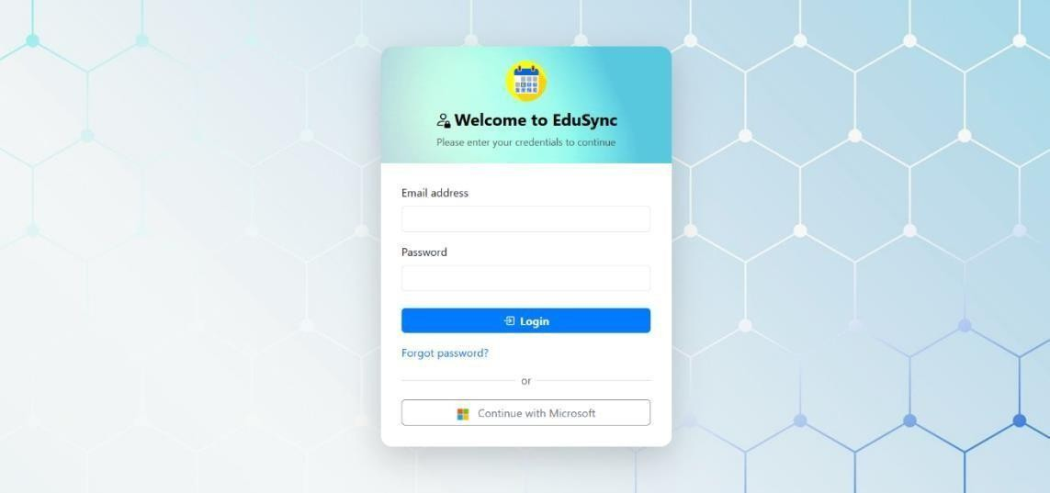

Figure 17: Login Page

When you log in for the first time, you will be directed to the Dashboard. Review your profile details and update them if needed. Take a moment to explore the navigation menu to get familiar with the system layout.

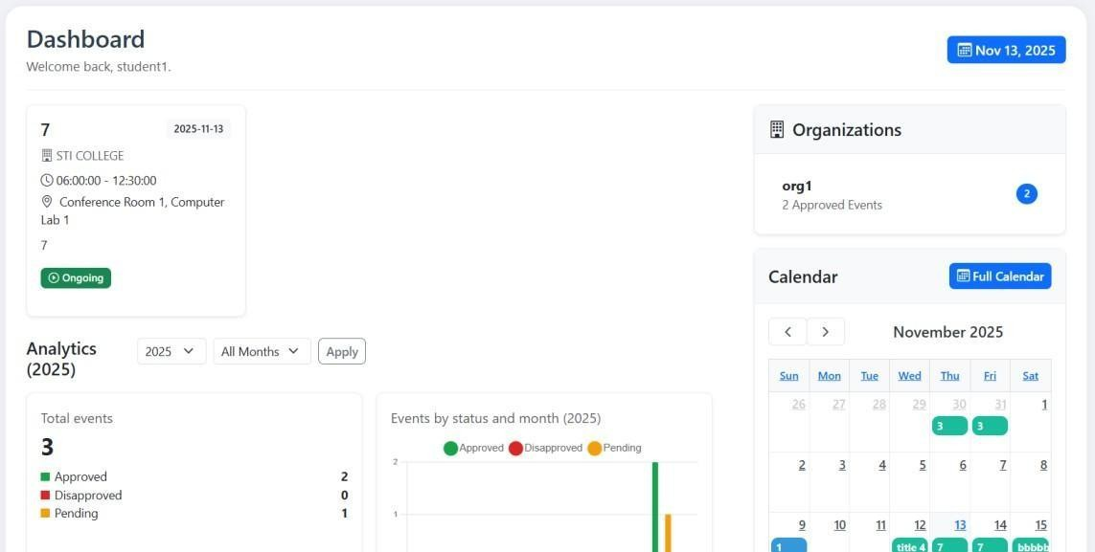

Figure 18: Dashboard

The Dashboard provides an overview of your proposals, including those that are pending, approved, or disapproved. It also displays upcoming and current events, as well as monthly trends that show your proposal submissions over time.

Creating a Proposal

To create a new proposal, click Activity on the navigation menu, then select Create New Proposal or the “+ Add Activity” icon. You will be taken to Step 1 of the proposal form.
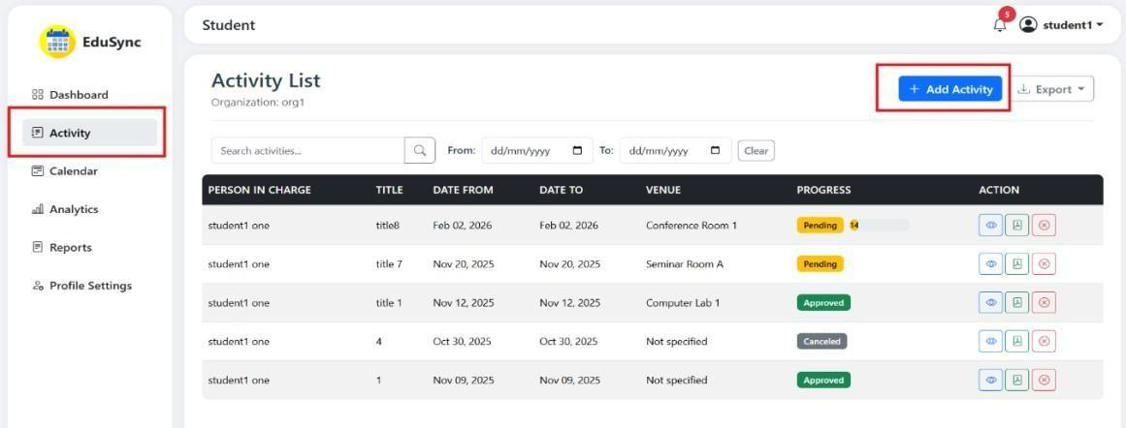
Figure 19: Activity Module

In Step 1, fill in the basic details of your activity, such as the title, objective, type (minor, major, or school-wide), organization, person in charge, and expected reach. Choose your start and end dates carefully, following the system’s minimum day requirement and avoiding blocked schedules. After completing all required fields, click Next to continue.
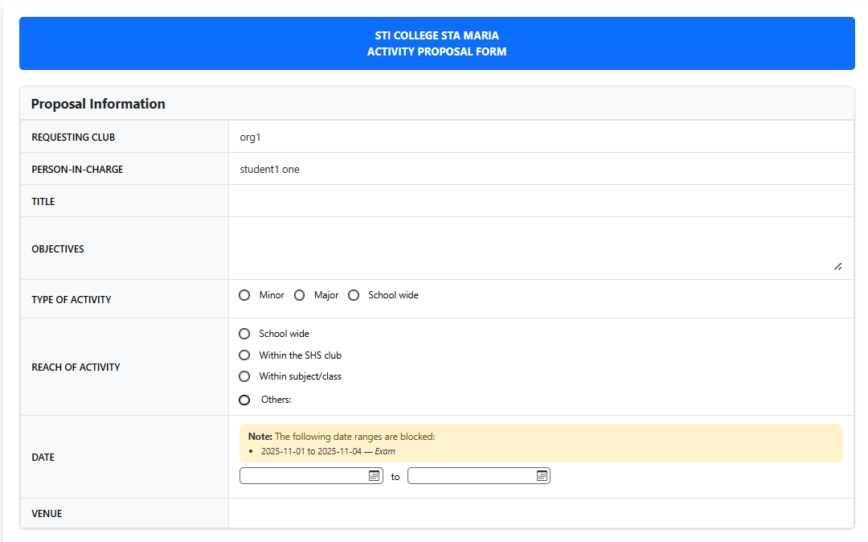

Figure 20: Activity Proposal Form

In Step 2, set up the schedule for your event. Click Add Day to include specific event days, then provide the date, time, description, and venue. You can also list the items you wish to borrow from the inventory. The system automatically checks the availability of venues and items to avoid conflicts.

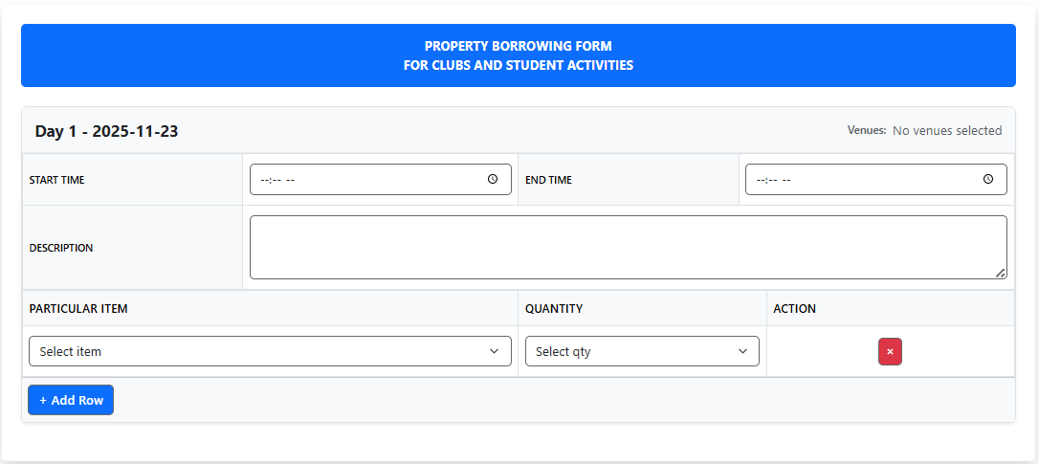

Figure 21: Property Borrowing Form

Step 3 allows you to add budget details if needed. Click Add Budget Item, then input the product or service name, quantity, and unit price. The total will be computed automatically. You may also upload a price reference image for transparency. After reviewing, click Next to proceed.
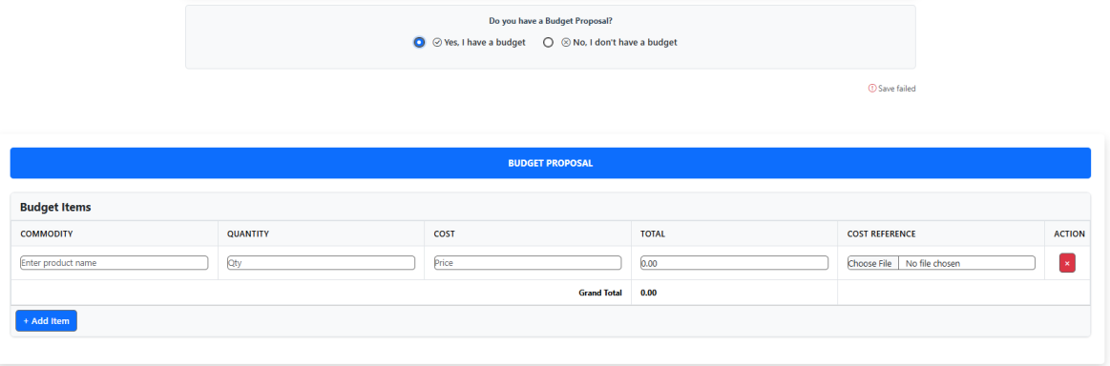

Figure 22: Budget Proposal Form

Before submission, review all entered details, including activity information, event schedule, and budget items. When everything is correct, click Submit Proposal. The system will confirm submission and set the status to Pending. Approvers will receive notifications for review.

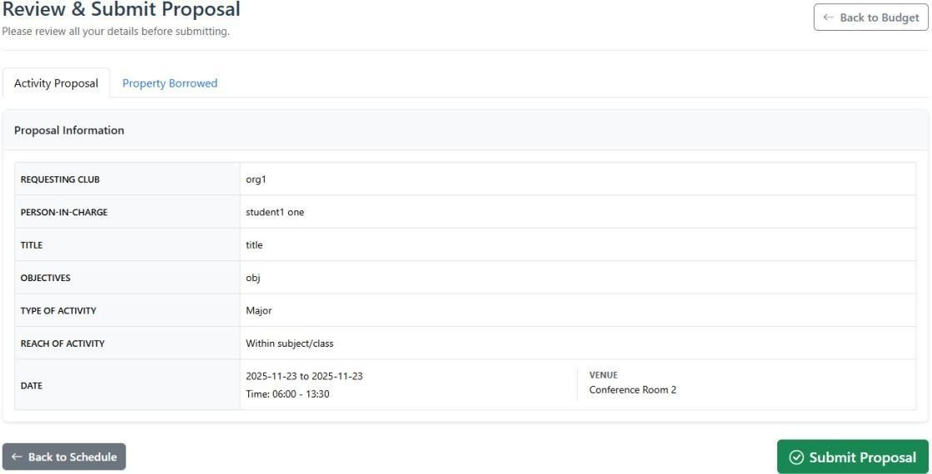

Figure 23: Filled Activity Form

Managing Proposals

To view your submitted proposals, go to the Activity section. All proposals are listed with their title, status, submission date, and approval progress.
Insert Screenshot Here

Click the proposal view button to view its complete details, including schedule, venues, budget, and approver comments.
Insert Screenshot Here

You may edit a Pending proposal or one marked for Revision. Click "Edit," make the necessary changes, and resubmit. Approved or disapproved proposals can no longer be edited.
Insert Screenshot Here

To download a proposal, open its details and click Download PDF. To delete one, click Delete and confirm. Only pending proposals can be removed.

Insert Screenshot Here

Calendar View

You can access the Calendar through the navigation menu to view all approved and pending events. Approved events are shown in green, while pending ones appear in yellow.
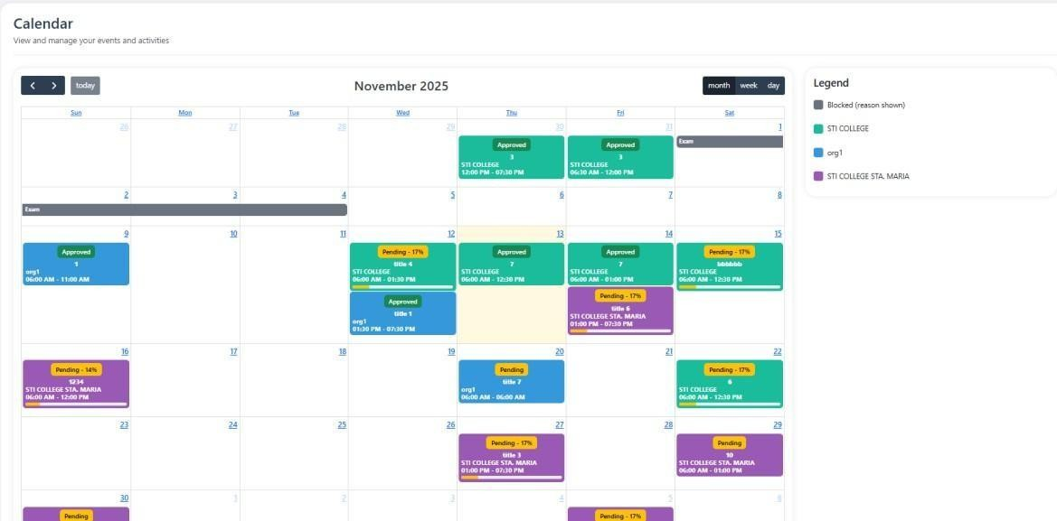

Figure 24: Calendar

Use the arrow buttons to navigate between months and click on an event to see details. The calendar also helps you detect possible venue conflicts.

Profile Management

To update your personal information, click your profile icon, choose Edit Profile, and edit your name, email, department, or organization. Click Save Changes afterward.

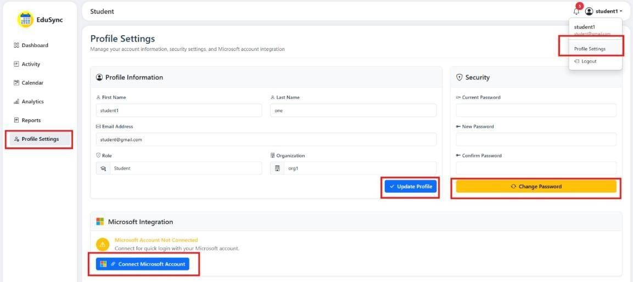

Figure 25: Profile Settings

To change your password, go to Profile > Change Password, enter your current password, type the new one, and confirm. Click Update Password to save.
You can also link your Microsoft account under Profile > Microsoft Accounts. Click Link Account, authorize the connection, and your Microsoft account will be added. This enables email notifications and smoother access to Microsoft tools.

Reports

After an event is approved and completed, go to Reports to submit a post-event report. Select your proposal, click Submit Report, and fill out the narrative, evaluation, and financial sections. You may also attach supporting documents before submitting.

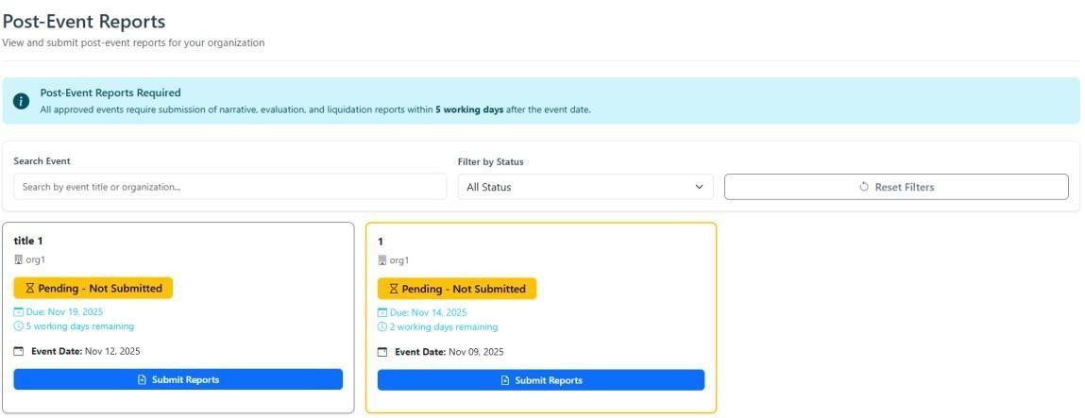

Figure 26: Post Event Reports

To view or download reports, open the Reports section and click the desired report. A PDF version can be downloaded for reference.

Approver Guide

- Reviewing Proposals

To access pending proposals, click Activity or Proposals from the menu. The system automatically filters proposals based on your category — organization-specific for Advisers, department-based for Program Heads, or global visibility for higher-level approvers like the SAO or Academic Head.
Click the proposal view button to view its details. You will see all basic information, such as the activity title, objectives, type, and dates. Event schedules, budget breakdowns, and approval progress are also displayed, along with previous approval decisions made by other approvers.
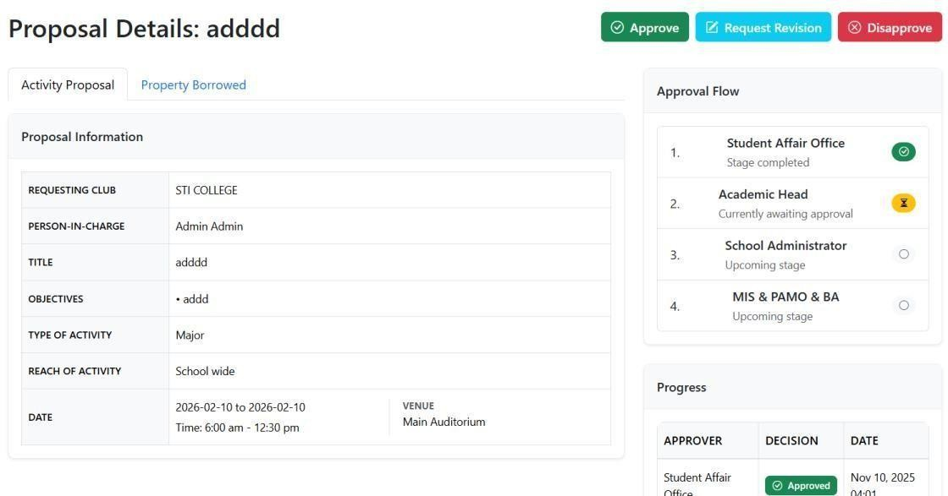

Figure 27: Proposal Details

Proposals follow a sequential approval process, moving through stages from Adviser to Student Affairs Office, Program Head, Academic Head, and finally to global approvers like MIS, PAMO, BA, and the School Administrator. Each stage must be completed before the next one begins. You can only approve proposals when it is your turn in the sequence.

Making Approval Decisions

To approve a proposal, open its details, review all sections, and click Approve. You may add comments before confirming. After approval, the proposal automatically moves to the next stage, and notifications are sent to the concerned users.
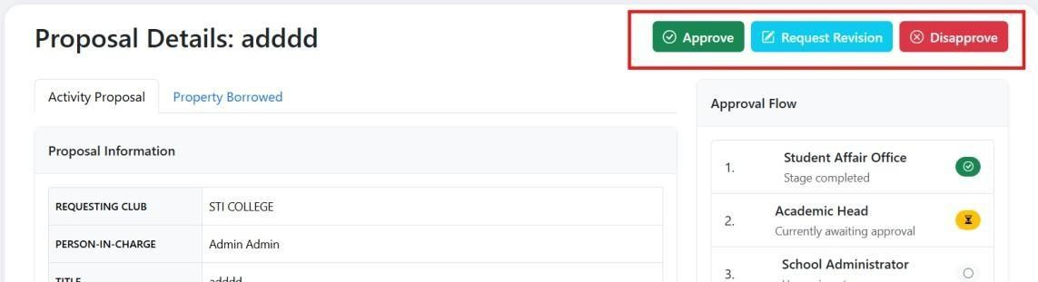

Figure 28: Proposal Details – Approval Section

If a proposal does not meet requirements, click Disapprove, provide a reason in the comment box, and confirm. The system will immediately mark the proposal as Disapproved, stopping the approval process.
You can also request revisions. Click Request Revision, select the target user (creator or person in charge), choose which fields to revise, and write specific comments. The proposal remains pending while the creator edits only the marked fields.
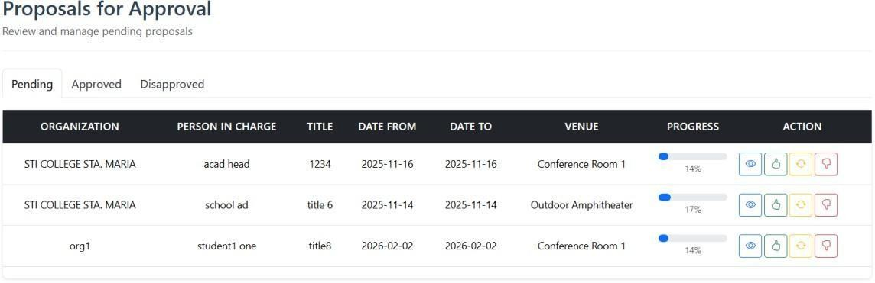

Figure 29: Proposal List

If necessary, you may change your decision before final approval. Update Decision, select the new status (Approved, Disapproved, or Revision), edit comments if needed, and click Update.

Approval Workflow

The system uses a sequential approval flow, meaning each stage must finish before the next begins. Approvers within the same stage can act in parallel.
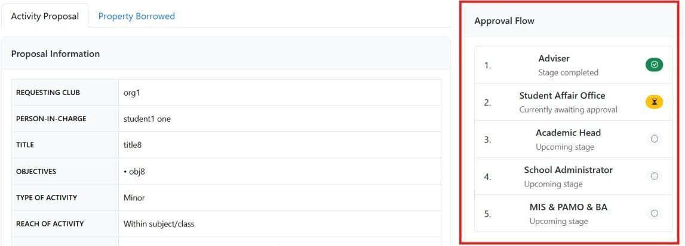

Figure 30: Flow of Approval

Proposal statuses include Pending, Approved, Disapproved, and Canceled. The system updates these automatically as decisions are made.

Figure 31: Progress of Approval

You can view progress in percentage form on the proposal details page. It shows which categories have been approved and which stages remain pending.

Reports

In the Reports section, approvers can view post-event submissions such as narrative, evaluation, and financial reports. These can be reviewed directly or downloaded as PDFs.

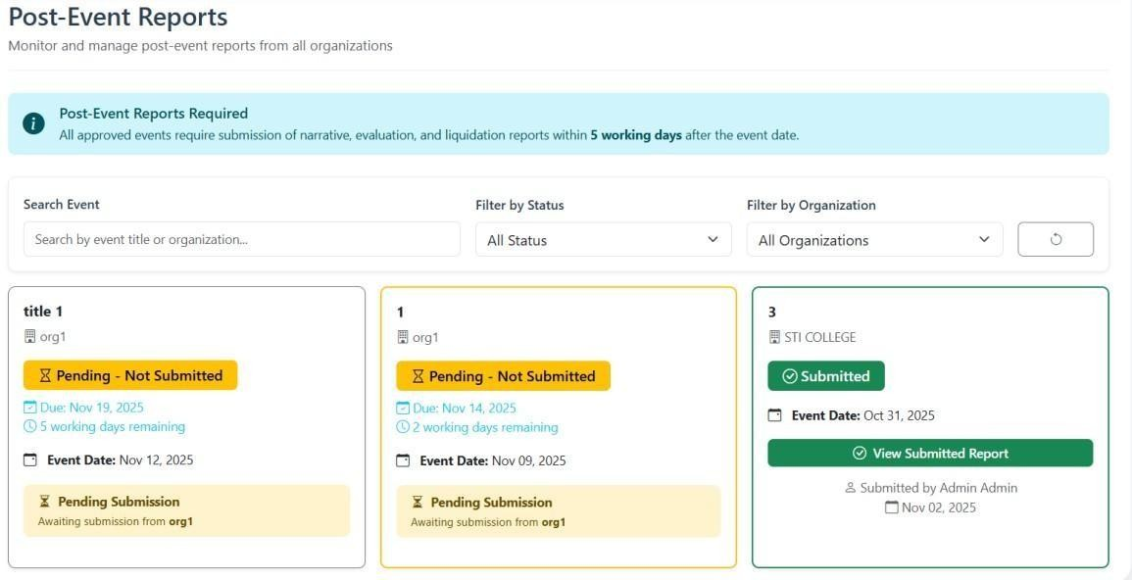

Figure 32: Post Event Report List

Reports can also be generated within specific date ranges and exported in various formats, including PDF, CSV, and Word.
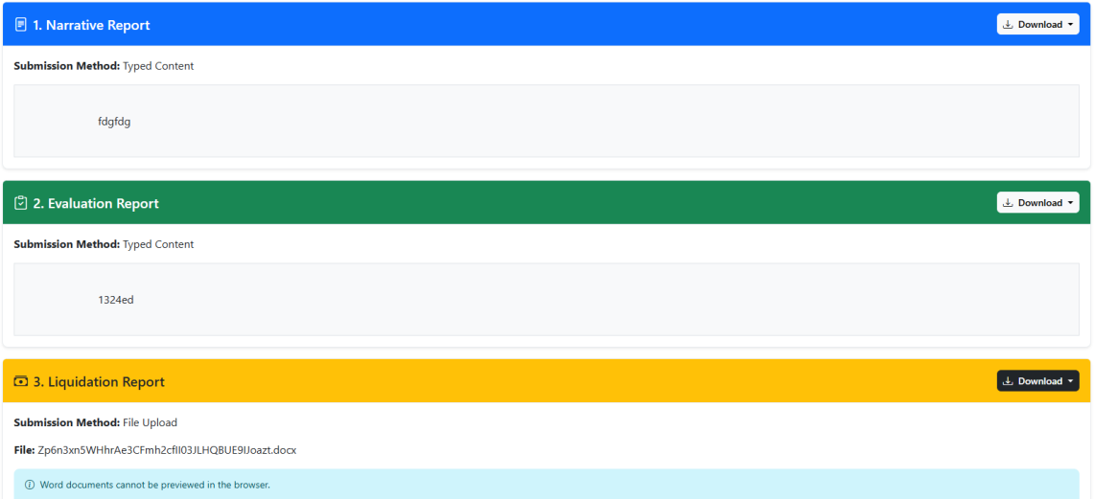

Figure 33: Post Event Report Submission

Admin Guide

- User Management

In the navigation menu, click Users to view all registered system users. Each user entry displays essential details, including name, email, role (Student, Approver, or Admin), approver category, department, organization, and current status.
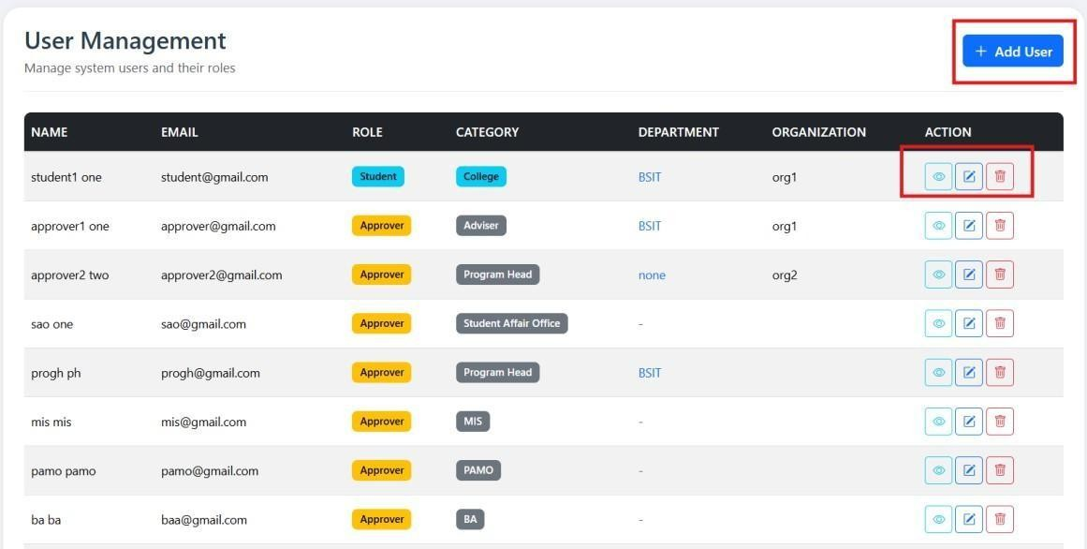

Figure 34: User Management

To create a new user, click Add User and fill out the form with the user’s first name, last name, email, and initial password. Select the user’s role and approver category if applicable. Assign a department and organization, then click Create User to save.
To update a user’s details, click Edit beside their name. You can modify their name, email, role, category, department, organization, or status. Click Save Changes to apply updates.

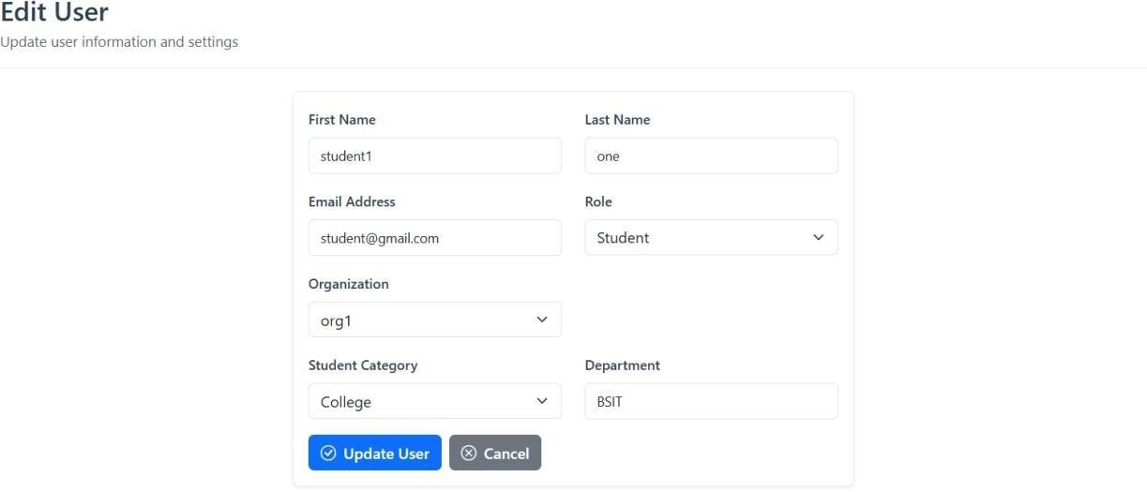

Figure 35: Modify User Setting

When a user forgets their password, select Reset Password, enter a new one, and confirm. The user must use this new password during their next login.
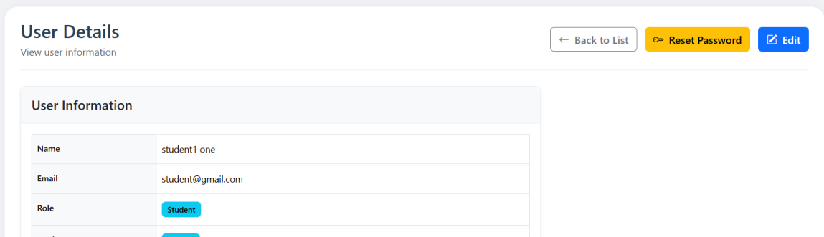

Figure 36: User Details

If a user account must be removed, click Delete and confirm the action. However, it is often better to deactivate the account instead of deleting it, as deletion may affect existing proposals or related data.

Organization Management

Administrators can view all student organizations by clicking Organizations in the menu. The list displays each organization’s name, department, president, adviser, level, and total members.
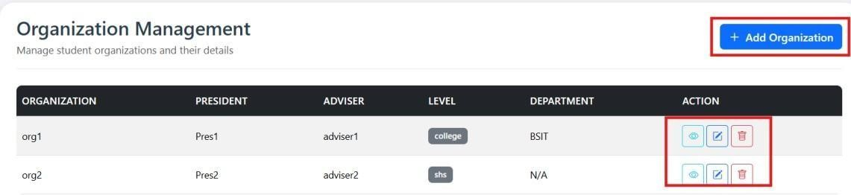

Figure 37: Organization Management

To add a new organization, click Add Organization, then fill in the organization name, department, president, adviser, level, and member list. Click Create Organization to save.
To modify an organization, click Edit, update the necessary details such as name, adviser, or members, then click Save Changes.
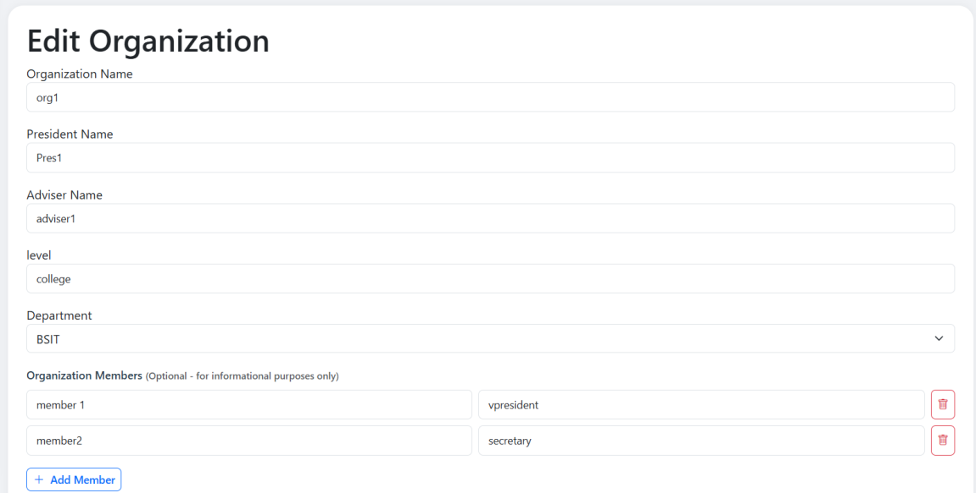

Figure 38: Modify Organization Setting

If an organization must be removed, click Delete and confirm. Note that deleting an organization may affect its proposals and related data.
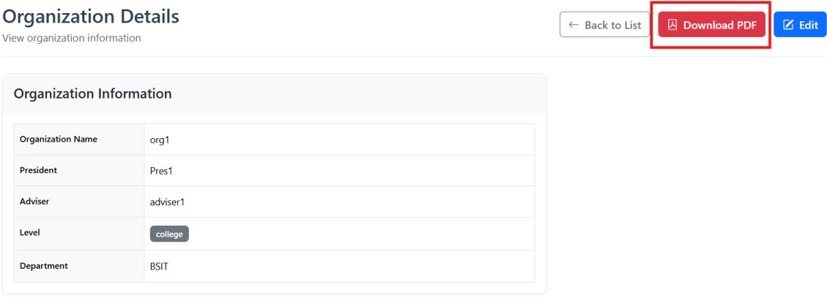

Figure 39: Organization Details

Admins can also download a full Organization PDF Report by clicking Download PDF. The exported file includes the organization’s profile, officers, members, and activity statistics.

Venue Management

Under Venues, admins can manage all event locations used in proposals. The venue list includes the name, capacity, location, availability, and status.
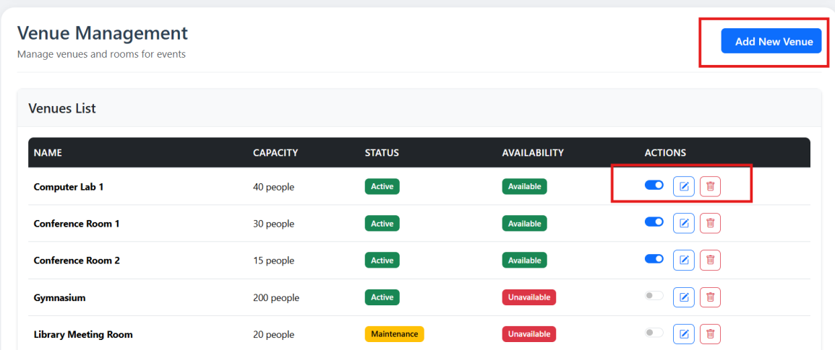

Figure 40: Venue Management

To create a new venue, click Add Venue, enter the name, capacity, location, and availability, then click Create Venue.
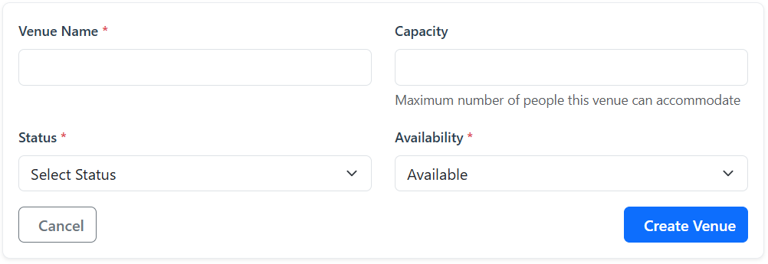

Figure 41: Add Venue

To update an existing venue, click Edit and adjust the necessary information such as name, capacity, or location. Click Save Changes to confirm.
To temporarily disable a venue, click Toggle Availability. Venues marked as unavailable will not appear in proposal submissions until reactivated.
When deleting a venue, click Delete and confirm. Be cautious, as removing a venue may affect existing proposals that use it.

Inventory Management

Click Inventory in the navigation menu to access all available items used for events. Each inventory item displays its name, total quantity, number of damaged units, and available count.
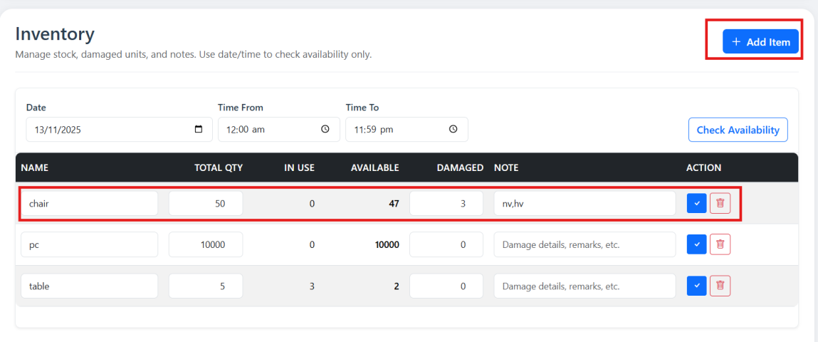

Figure 42: Inventory – Add Item

To add a new inventory item, click Add Item, enter the name, quantity, and a brief description, then click Create Item.
To modify an item, click, update its quantity, damaged count, or description, and then click Check.
Admins can also update damaged items by selecting Update Damaged, entering the new number, and clicking Update. The system automatically recalculates available quantities.
To remove an item, click Delete and confirm. Be cautious, as deleting items may impact related proposals.

System Settings

Open Settings from the menu to configure system behavior and restrictions.
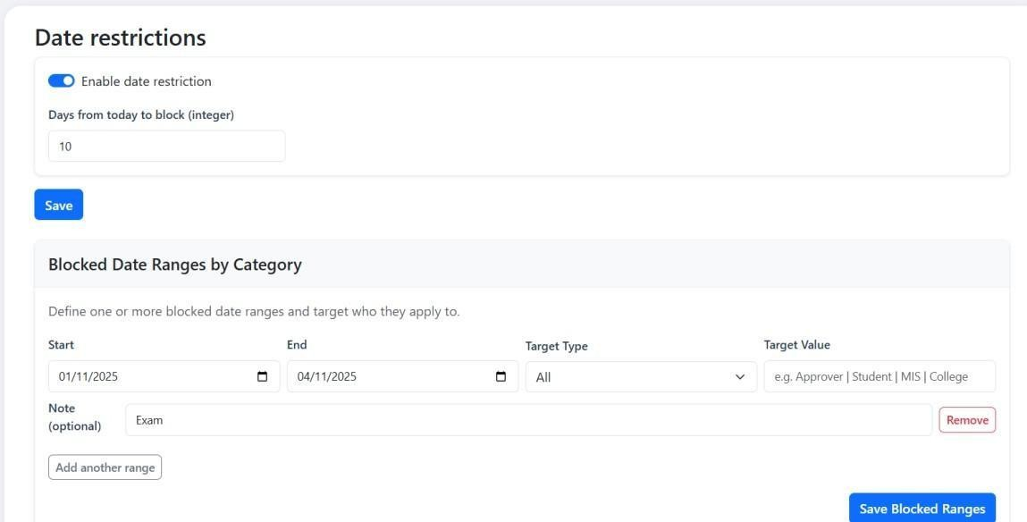
Figure 43: Date Restriction Setting

Admins can enable or disable Date Restrictions to control when proposals can be submitted. You can specify the minimum number of days required before an event and add Blocked Date Ranges for holidays or examinations. Provide a reason for blocking dates, then click Add Blocked Range.

Role and Permission Management

Click Roles to view all available user roles, including Student, Approver, and Admin.

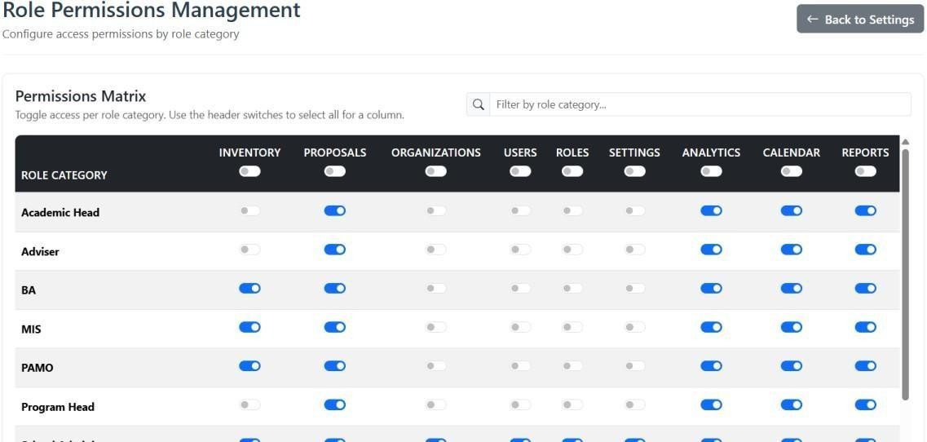

Figure 44: Role Permission Management

Under Role Permissions, select a role to manage access rights. Permissions include access to Inventory, Proposals, Organizations, Users, Roles, Settings, Analytics, Calendar, and Reports. After setting privileges, click Save Permissions to apply.

Appendix D: Diagrams

Flowchart Diagram Old Process
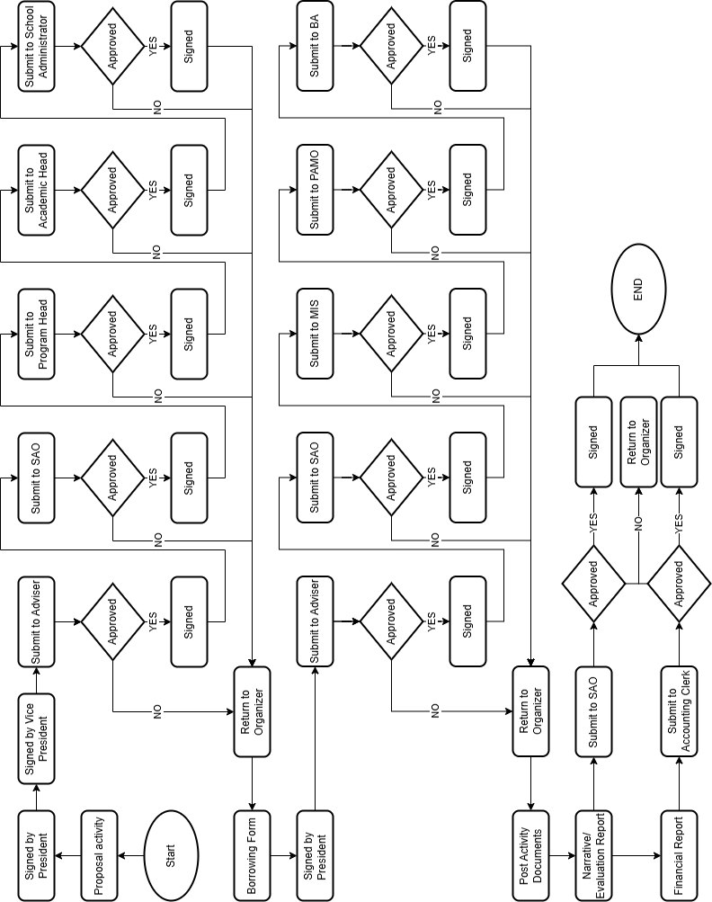

Figure 45: Old Process

Student Level
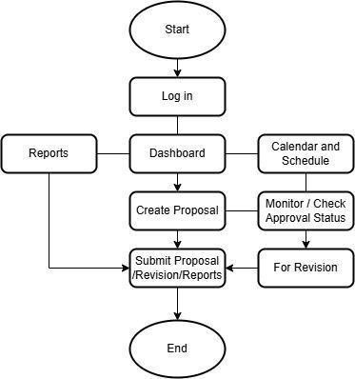

Figure 46: Student Level

Approver Level
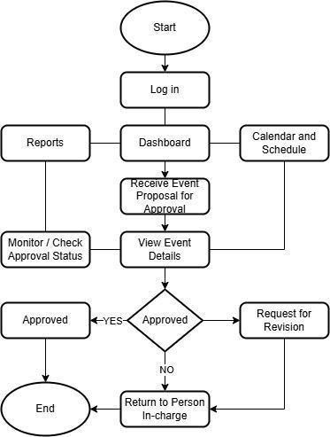
Figure 47: Approver Level

Administrator Level
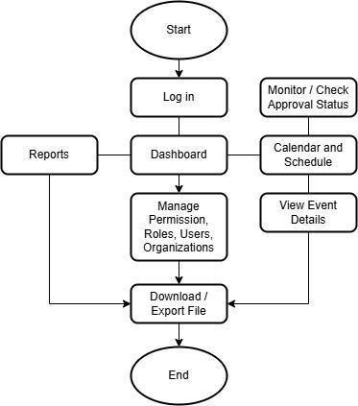
Figure 48: Administrator Level

Context Diagram
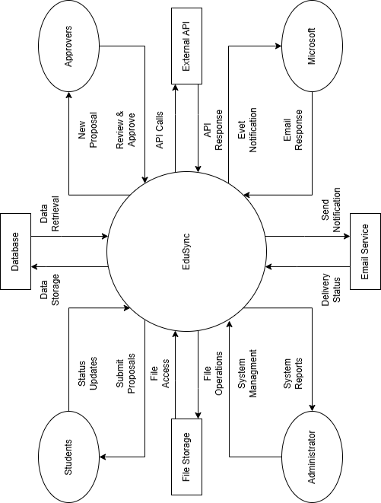

Figure 49: Context Diagram

Entity Relationship Diagram

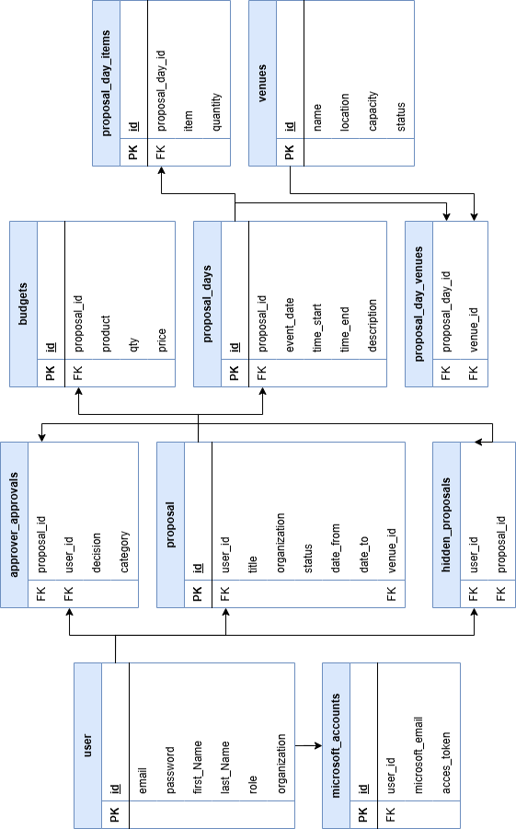
Figure 50: Entity Relationship Diagram

Data Flow Diagram

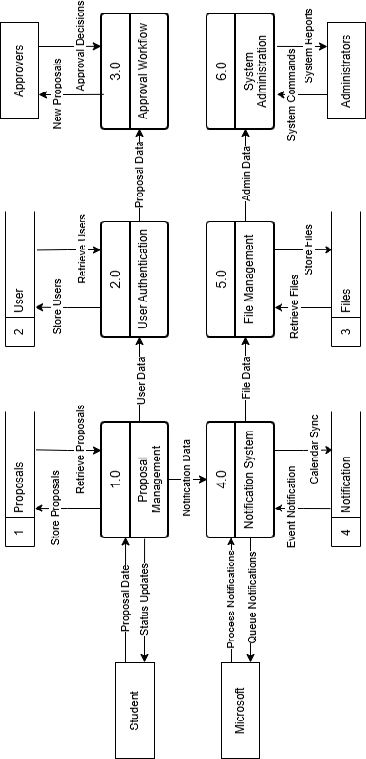
Figure 51: Data Flow Diagram

Appendix E: Grammarian Certificate

Appendix F: Plagiarism Scan Report

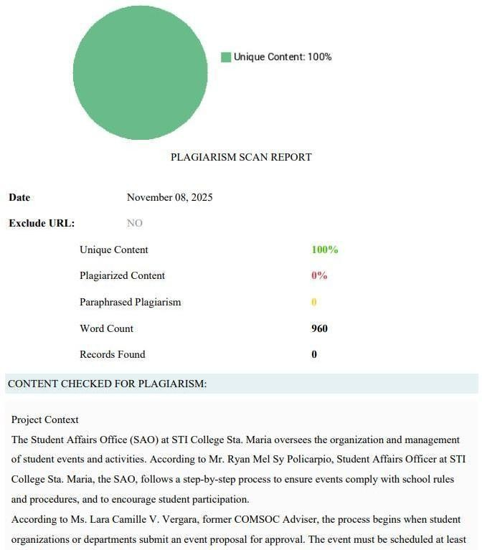
Figure 52: PrePostSEO Plagiarism Checker
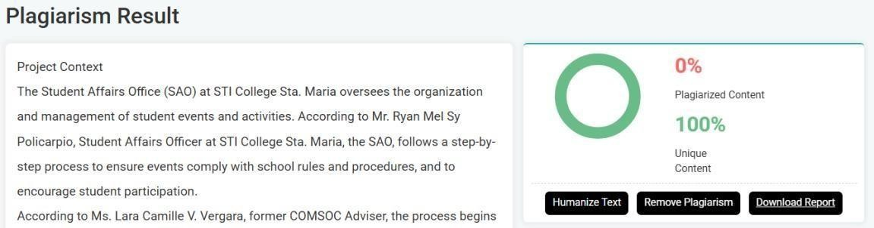
Figure 52.1: PrePostSEO Plagiarism Checker

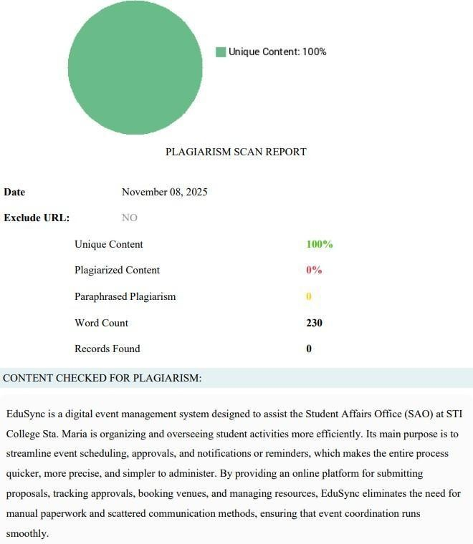
Figure 52.2: PrePostSEO Plagiarism Checker
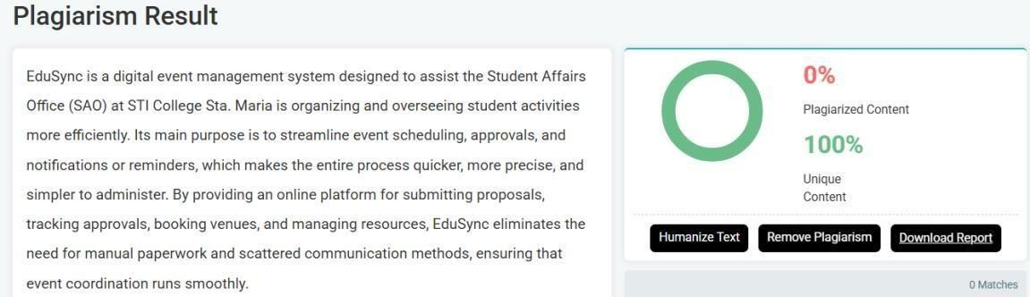
Figure 52.3: PrePostSEO Plagiarism Checker

Appendix G: Test Case Scenario

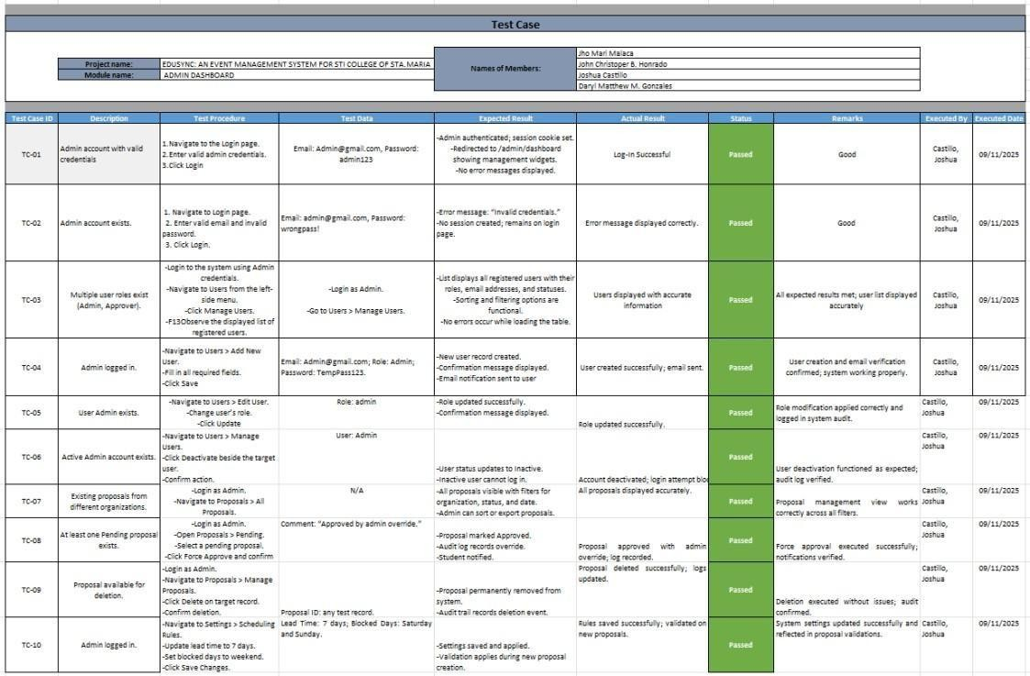
Table 15: Admin Level
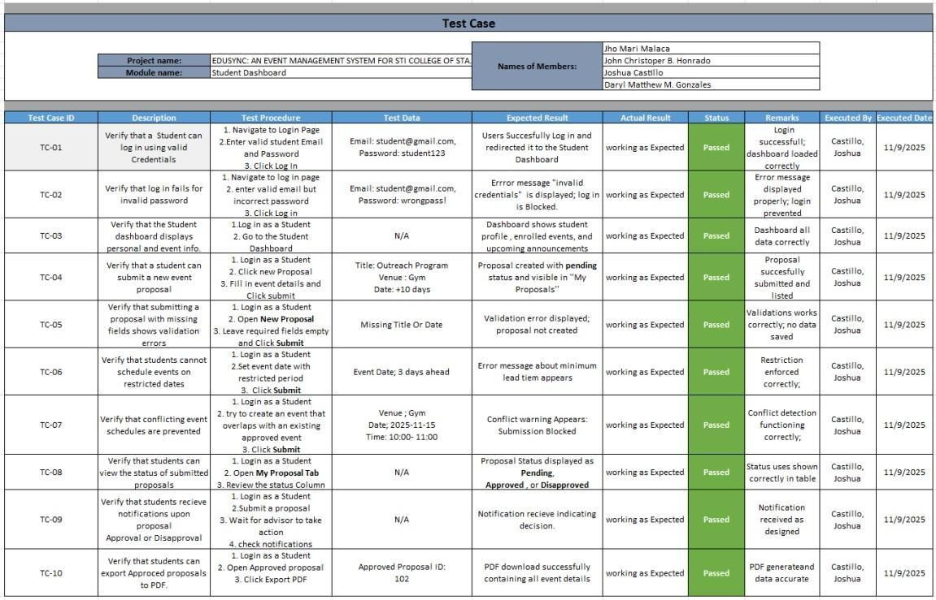
Table 16: Student Level

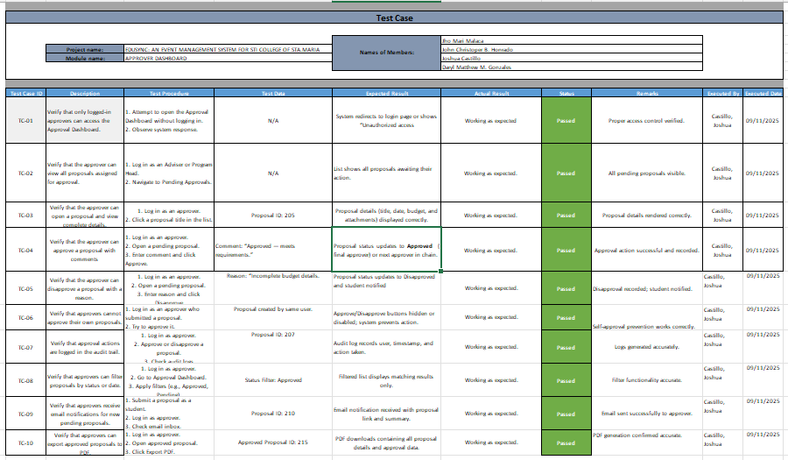
Table 17: Approver Level

Appendix H: Personal Technical Vitae


Curriculum Vitae of

Jho Mari M. Malaca

Mahobany St., Mahabang Parang, Santa Maria, Bulacan jhomarimalacamatuguinas@gmail.com
0965 710 9042

EDUCATIONAL BACKGROUND
Level Inclusive Dates Name of school/ Institution Tertiary

Vocational/Technical Senior High School
N/A
2018 Immaculate Conception Polytechnic

High School 2016 Parada National High School
Elementary 2012 San Gabriel Elementary School

SKILLS

SKILLS | Level of Competency | Date Acquired
Java Fundamentals | Competent | June 2023
Systems Administration | Competent | June 2023
Introduction of SQL | Intermediate | September 2024
C# | Intermediate | June 2024

TRAININGS, SEMINARS, OR WORKSHOPS ATTENDED
Inclusive Dates Title of Training, Seminar, or Workshop
December 2024 Game Development: The Ultimate Power-up: Combining Education and
E-sports


Curriculum Vitae of

John Christopher B. Honrado

0780 Kalsadang Munti, Catmon, Sta. Maria Bulacan honrado.john11@gmail.com
0995 588 4529

EDUCATIONAL BACKGROUND

Level | Inclusive Dates | Name of school/ Institution
Tertiary
Vocational/Technical | N/A
High School | 2022 | Catmon, National High School
Elementary | 2016 | Jose Juan Serapio Elementary

SKILLS

SKILLS | Level of Competency | Date Acquired
Java Fundamentals | Competent | June 2023
Systems Administration | Competent | June 2023
Introduction of SQL | Intermediate | September 2024
C# | Intermediate | June 2024

TRAININGS, SEMINARS, OR WORKSHOPS ATTENDED
Inclusive Dates Title of Training, Seminar, or Workshop
December 2024 Game Development: The Ultimate Power-up: Combining Education and
E-sports


Curriculum Vitae of

Joshua Castillo

348, Gulod 1, San Jose Patag, Sta. Maria, Bulacan juswacastillo@gmail.com
0931 008 7373

EDUCATIONAL BACKGROUND

Level | Inclusive Dates | Name of school/ Institution
Tertiary | N/A | N/A
Vocational/Technical | N/A | N/A
High School | 2022 | Aquinas De Escolar Academy
Elementary | 2016 | San Jose Patag Elementary School

SKILLS

SKILLS | Level of Competency | Date Acquired
Java Fundamentals |  | 2023
System Administration |  | 2023
Best Libero |  | 2025

TRAININGS, SEMINARS, OR WORKSHOPS ATTENDED

Inclusive Dates Title of Training, Seminar, or Workshop
2024 Game Design


Curriculum Vitae of

Daryl Matthew M. Gonzales
03 brgy. Matictic, Norzagaray, Bulacan darzg2k13@gmail.com
0977 755 4722

EDUCATIONAL BACKGROUND
Level Inclusive Dates Name of school/ Institution Tertiary N/A

Vocational/Technical Senior High School
N/A
2020 Colegio de Sta. Monica de Angat

High School 2018 Colegio de Sta. Monica de Angat Elementary 2013 Shechem Inc.
SKILLS

SKILLS | Level of Competency | Date Acquired
Java Fundamentals | Competent | August 2022
Systems Administration | Competent | August 2023
Introduction of SQL | Competent | September 2023
C# | Competent | February 2023
Web Development | Competent | November 2025

TRAININGS, SEMINARS, OR WORKSHOPS ATTENDED
Inclusive Dates Title of Training, Seminar, or Workshop
April 2025 On-the-job training at Vastresult Inc.

